**Chapter 1: China Watch, Disguised Chinese Propaganda, and the American Media Landscape**

***“Wherever the readers are, wherever the viewers are, that is where propaganda reports must extend their tentacles.” — Xi Jinping, February 2016***

**Background**

Since 2010, the Chinese government has begun to make use of a novel type of political propaganda in their efforts to affect international public opinion about China, paid news supplements written by the Chinese state that later appear in international media sources. Coined “*China Watch*,” these supplements have historically been provided by *China Daily*, a Chinese government-controlled English-language newspaper, and paid for the *China Daily’s* owner, the Chinese government. Although it is unclear exactly how many of these supplements have since appeared in Western media since their first appearance in early 2010, it is known that, as of March 2018, *China Watch* supplements have appeared in at least 40 international media outlets in over 20 countries (Dai and Luqiu, 2020). These media outlets include many establishment, legacy newspapers, such as the *New York Times,* the *Washington Post*, and *The Wall Street Journal*. According to Justice Department documents, *China Daily* paid approximately $19 million dollars to American media organizations between November 2016 and April 2020 for the purpose of publishing *China Watch* supplements. Payments included $4.6 million to the *Washington Post* and nearly $6 million to the *Wall Street Journal* alone.

Although the Chinese government has circulated *China Watch* in Western media channels for over a decade, it is only until recently that *China Watch* has gained attention in American security and political channels. In the leadup to the midterm November 2018 elections, China purchased a four-page insert in Iowa’s *Des Moines Register*. This insert, not so subtly, sought to soften China’s image among Iowans at the expense of the then-president, Donald Trump, including articles with headlines like “Book tells of Xi’s fun days in Iowa,” “China seeks pacts on robotics,” and “Dispute: Fruit of a president’s folly” (Funk, 2018). President Trump would later tweet a photo of the *China Watch* insert that ran in the *Des Moines Register* to his over 60 million followers, labeling it as propaganda and a Chinese attempt to interfere in the upcoming 2018 election. This Trump tweet brought a multitude of attention onto *China Watch* supplements and other versions of “political native advertising,” or paid political advertisements camouflaged as standard editorial content (Dai and Luqiu, 2020). Today, most major Western newspapers, including the *New York Times* and the *Washington Post*, have publicly announced that they will no longer be running *China Watch* supplements either in their newspapers or on their websites. Furthermore, as of February 2020, *China Daily* as well as other Chinese state-run media outlets have been placed on a restricted list by the U.S. government limiting the number of employees they can have in the U.S. after the Trump administration accused these Chinese media outlets as spreading propaganda for the CCP.

Despite the large literature on political propaganda and international relations, there exists little research on political native advertising. By design, native advertisements—oftentimes called sponsored content by the private sector—are supposed to be nearly indistinguishable from newspaper editorial output. While political native advertisements may not be classifiable as hard propaganda that is easily detected, like government-sponsored nationalist commercials, it should certainly fall in the category of soft propaganda. For instance, *China Daily* is formally managed by the State Council Information Office, a subdepartment under the supervision of Publicity Department of the Chinese Communist Party (otherwise called the CCP’s Propaganda Department) (Hartig, 2017). Previously, both *China Daily* and *China Watch* supplements have both been labeled as advanced instruments of China’s foreign-facing propaganda network (ibid). Therefore, *China Watch* articles serve as both a promising unit of analysis in of itself and as useful proxy to further investigate how Chinese state approaches at mediating American opinion have fared in the past decade.

This chapter seeks to answer the question of whether *China Watch* supplements have had any effect on American attitudes toward China in the time they have been inserted into American media outlets. By extension, I seek to seek to add to a growing set of literature that researches the efficacy of Chinese state efforts at mediating international public opinion about China. In this chapter, I begin by providing context about how American public opinion toward foreign countries is thought to be traditionally formed as well as the mechanisms by which propaganda might actually be persuasive, thereby mediating individuals’ attitudes about China. Next, I discuss on online survey experiment designed with a real *China Watch* advertisement featured in *The Telegraph* in 2018. This survey experiment sought to receive data that would aid in answering a number of research questions. Do readers consider *China Watch* advertisements to be persuasive? Are readers’ attitudes toward China and policy preferences regarding American foreign policy relating to China mediated? Does it matter the American media source in which *China Watch* is placed into? Will a *China Watch* advertisement featured in an establishment newspaper like the *New York Times* appeal to a different American audience than a *China Watch* advertisement placed in Fox News?

I find that *China Watch* supplements, compared to direct statements by the CCP, fail to mediate Americans’ attitudes toward China or policy preferences about American foreign policy regarding China. Moreover, I find that exposure to *China Watch* articles actually shifts attitudes toward China in the negative direction, prompting Americans to have less favorable views of China overall and to endorse more antagonistic, tension-inducing foreign policy. I also find that the media source in which *China Watch* inserts are placed in matters for mediating attitudes—Americans attitudes shift most negatively when *China Watch* is depicted as inserted into an establish newspaper and shift least negatively when the *China Watch* adverts are depicted as placed on social media of conservative media platforms. Utilizing regression analysis, I also was able to analyze the role that demographic variables and media interaction has one’s attitudes about China after exposure to *China Watch*. I find that race, partisanship, overall time spent engaging with the news, and beliefs in media conspiracy theories often explain Americans attitudes about China, regardless of exposure to political native advertising. In a second study focusing on the effect political speeches and comments from Chinese president Xi Jinping might have on attitudes toward China, I find that these same covariates are robust and explain Americans’ perceptions of threat from ethnic Chinese and Chinese Americans living within the United States.

This study makes several contributions. First, its results show that greater exposure to Chinese state propaganda will likely not have induce Americans to have more favorable views of China and may actually have an effect in the opposite direction. This finding would imply that Americans view China with previously set definitions and that their attitudes are not malleable through Chinese state efforts. Second, this research ties into a number of ongoing debates in political science relating to the formation of domestic public opinion about international affairs. This study’s findings suggest that as compared to the traditional models of public opinion which assumed rational evaluation of foreign policy by Americans, Americans are more likely to assign attitudes about foreign countries through an integrated threat determination. Third, this research has implications for American public policy. Results from this study suggest that United States policymakers need not be particularly concerned about the threat of Chinese propaganda in mediating the majority of Americans views to trust or even like China.

**Persuasion, Media Sources, and Propaganda**

Persuasion directly relates to propaganda because persuasion has to do with cognition and the active assessment of a message’s content. It involves changing minds, opinions, and attitudes about causality as well as modifying identity through non-coercive means. As communication theorist Richard Perloff puts it, persuasion is an “activity or process in which a communicator attempts to induce a change in the belief, attitude, or behavior of another person… through the transmission of a message in a context in which the persuade has some degree of free choice” (Perloff 1993). In the context of Chinese propaganda targeted at the United States, this propaganda aims to persuade Americans to reconsider and then change their views towards China in a positive affect direction. That is, persuasion attempts to close the distance between individual’s causal understandings of complex political affairs.

How persuasion actually works is a different matter, though. It is a topic of mutual interest for social psychologists, political scientists, communication theorists, and sociologists. Previously some communication theorists have even argued that persuasion is evident in all forms of social interaction and communication that involves altering “perceptions, attitudes, beliefs, and motivations” (Berger 1995). So as to narrow my discussion, I will focus only on connecting persuasion to how it might explain where and when Chinese propaganda will be effective. The best way to start is to review the literature on how an actor might be persuaded.

In general, persuasion can be successful through three distinct mechanisms. First, actors can engage in high-effort processes of cognition, reflection, and internal argument about the content of new information they are given (Bar-Tal & Saxe, 1990). Second, an actor can be persuaded because of his identity relationship to the persuader through a “peripheral” route. Here, the actor looks internally for cues about the nature of his identity relationship to the persuader before judging the legitimacy of counter-attitudinal arguments (Johnston, 2008). Third, and lastly, persuasiveness of a message can be channeled through the characteristics of the individual being persuaded himself. This can refer to the cognitive processing abilities of a persuasion target, the strength of existing attitudes and more. Some argue that all three of these mechanisms are necessary for successful persuasion (Lupia & McCubbins 1998).

Regarding the first channel described above in which an individual seriously grapples with new information, it seems most likely that this could only occur if that individual believed Chinese funded sources to be a truthful and legitimate sharer of information. This route of persuasion requires an individual to at least partially weigh evidence, puzzle through arguments counter to his previous beliefs, and come to a final conclusion different from his own. Persuasion is only effective when given internalized standards for evaluating the message gives it a positive evaluation. Arguments become more persuasive when they are systematic and are linkable to other internally held schema and attitudes (Petty et al. 1997; Wu and Shaffer 1987; Zimbardo and Leippe 1991). When environmental cues match internal validity checks of information’s veracity it becomes more likely for the actor’s affect to change. As such, the probability of successful attitude change through this cognitive process increases in an environment where new information cues linkages to preexisting positive attitudes and interests (Johnston 2008). Logically and countercyclically, if this new information is linked to preexisting negative beliefs about, say, a potential enemy or high-risk threat, then probability of acceptance goes down.

In the mechanistic route by which an actor is convinced because of her relationship to the agency or person attempting to engage in persuasion, the nature of the identity relationship between both parties is most important. In other words, we can reasonably expect that information from ingroups is more persuasive than information from outgroups. In the context of Chinese propaganda, this seem to suggest that Americans of Chinese ethnicity or that have cultural connections to China would be more likely to be persuaded by the information shared with them. It also suggests that people who identify with the content of the message being shared—such as a self-identified supporter of globalism identifying with content related to Chinese entry into international institutions—might be more easily persuaded. This finding is particularly true for novices who have little prior information about the issue being presented (Zimbardo & Leippe 1991). Additionally, information from recognized and respected authorities—such as scientists, religious leaders, doctors—will tend to be more convincing than if it had come from another source. In short, this identity focused mechanism for persuasion suggests that people will be more likely to be persuaded by sources that are “liked” than “unliked.” Liking something is highly correlated with ingroup identity, thereby bringing this mechanism full circle. If a piece of information is widely supported and agreed upon in an in-group then it becomes even more likely that an actor accepts that information as persuasive (Petty et al. 1997).

The most nebulous and expansive view on persuasion has to do with the persuasion target herself. Besides cognitive processing abilities and strength of existing attitudes, an individual might also value ideological consistency and therefore be resistant to changing a view that might lead others to interpret the actor as inconsistent or hypocritical (Wu & Schaffer 1987). In my view, this purported mechanism looks more like a catch-all term than a specific causal chain of persuasion. Therefore, the main takeaway I get from it in terms of its application towards Chinese propaganda is that researchers should stay cognizant of the social interaction between an individual’s prior traits and the variation, if any, in attitudinal change after exposure to Chinese propaganda.

Besides internal mechanisms of persuasion, the characteristics of the source from which information comes from is important too. Familiarity with a source, perceived authority of that source, and perceived trustworthiness all matter. A person is much more likely to be persuaded by a reputable acquaintance than a complete stranger, that is to say. Persuasion is also not necessarily a one-shot game. It can involve multiple games over an elongated time period. During this attempt at persuasion, the source of information is free and unconstrained in modifying its technique, including the content of the very information it is aiming to persuade an individual about. Therefore, the standard model of persuasion, as presented in Lupia and McCubbins (1998), argues that these described mechanisms and characteristics boil down into two crucial conditions: (1) that the persuade believes the persuader to be knowledgeable about an issue and (2) that the persuader’s intentions are perceived as trustworthy. This model has widely been accepted as a sort of rational, realpolitik view of persuasion.

This model, however, likely misses the mark in terms of addressing the role of social variables in modifying the efficacy of attempts at persuasion. For example, ideology, identity, and cultural variables all likely can interact with attempts at persuasion and either boost them or harm them. The model also leaves unanswered as to what mechanisms persuasion ultimately operate on. Although external forces to persuasion are undeniably important, research literature studying social psychology has shown that actors often do not rationalize their thoughts in a coherent and systemized fashion. In an arena of limited interactions through social media and American news media, it might seem that the importance of familiarity and other internal variables to the persuadee-persuader relationship should be discounted, but it could also be that identity, culture, and ideology become more critical for persuasion than external sources and costly signals. Either way, it is difficult to make an assessment without further empirical research without a reference to the often-odd nature of human psychology.

In sum, persuasion is likely some sort of combination of three processes. Through their logical interactions, it is simple to predict when persuasion might be more effective. These environments include situations in which an individual is highly motivated to analyze new information, when a persuader is an authoritative member of an ingroup which the individual is included in or wishes to be included in, when the individual is a novice in a new environment and is exposed to counter-attitudinal information repeatedly over time, and when the perceived threat from the persuader is viewed as being quite low. Does the Chinese state fit cleanly into any of these proposed environments? With the highly polarized, anti-China sentiment shared widely across the U.S. now, the answer is likely no except in cases in which the actor being exposed to propaganda is somewhere included in an ingroup that is supportive of Chinese state interests. A logical ingroup along these lines would be American born Chinese, or those Americans who still might have familial or cultural ties to China.

**Mass Opinion and Integrated Threat Theory**

In my view, there are still two possible families of theories that might explain how Americans will react to CCP external propaganda, in particular Americans without cultural ties to China. The first, and perhaps easier to understand, theory follows the mass opinion theory as presented by John Zaller in his 1992 book The Origins and Nature of Mass Opinion (J. R. Zaller 1992). As Zaller suggests, mass opinion is largely shaped by exposure to the media, which shares elite opinions on political issues. In the context of Chinese propaganda, this theory would suggest that the participant will feel more warmly towards China if he is sufficiently convinced that the information being shared is truthful. The second family of theories I aim to present can be characterized as an integrated threat theory, as written about by Walter and Cookie Stephan in 2000. Integrated threat theory refers to the phenomenon in which social groups that feel threatened by a perceived threat rather than an actual threat, which increases their levels of prejudice against the source of that threat, generally an outgroup. In the context of Chinese propaganda, this theory would suggest that the participant will feel less warmly towards China after exposure, perceiving China as a potential threat and outgroup to be prejudiced against. Although I am unsure which theory holds truer with regard to Chinese external propaganda, it would serve the reader well for me to give a quick introduction to each and how, in particular, they might interact with the mechanisms that change an individual’s political attitudes.

Due to new technologies like the internet and social media, it has become easier than ever for foreign countries to directly interact with American citizens so as to influence American public opinion. As to why China has decided to specifically target American media sources with their external propaganda, it appears that the CCP believes, like many political scientists, that the apparent source of information matters just as much as the content of information itself.

The Zaller “receive-accept-sample” model of public opinion, as described previously, particularly applies to media issues. According to researchers, media reporting can effectively change people’s expressed opinions through a process of priming and framing (Iyengar and Kinder, 1987). Altogether, this research suggests that media narratives and media reporting on public interest issues can play a role in dictating public response to policy issues, including foreign policy positions. If Chinese propaganda was to effectively disguise itself as written by a legitimate news source or if were to imply that the trusted news source endorsed the propaganda in some fashion, it is likely that this propaganda could have an outsized effect on American public opinion towards China.

The alternative family of theory I am working from is based upon integrated threat theory (ITT), also known as intergroup threat theory. This theory attempts to describe how situations of perceived threat between social groups can lead to prejudice. The basic threat model includes two types of threat that can potentially play a role in causing prejudice: realistic threats and symbolic threats (Stephan et al. 2002). Realistic threats are those that pose a danger to the in-group’s well-being, including economic and political power. Symbolic threats are those that arise when an ingroup feels that an outgroup poses an existential threat to their group identity, including morals, beliefs, or attitudes. This theory has been empirically supported by a number of experiments. In one study conducted by Esses et al., the researchers found that after exposing research participants to newspaper articles about a collapsing job market, research participants held more negative attitudes towards immigrants and were less supportive of immigration in general, suggesting that these participants interpreted the news being shared as some sort of threat (Esses et al. 2006). In the context of China, it is possible that after Americans read CCP propaganda that emphasizes the success of the Chinese economy, they would feel a realistic economic threat coming from the success of the Chinese nation, leading to an overall decrease in attitudes towards China. Therefore, this theory would suggest that Chinese external propaganda is backfiring by exposing more Americans to positive news stories about a rival, triggering a perception of real or symbolic threat and thereby leading to a decrease in American attitudes toward China.

The application of integrated threat theory to describe U.S.-China relations in the twenty-first century is not new. In fact, scholars have previous coined the term “China threat” to characterize China’s emergence as an economic and militaristic threat to the national interests of the United States (Broomfield 2003).

Authors that subscribe to this theory of thought believe that China—like other rising states—is apt to adopt an increasingly ambitious international strategy that imperils U.S. interests as its relative power grows. China hawks see evidence that from 2009 to the first half of 2020, China-U.S. relations have experienced a gradual yet sustained downtown in almost every dimension (Jisi and Ran 2019). One Chinese political scientist describes US-China relations as a “strategic competition… because China is closing the national power gap” (Zhao 2019). As tensions develop, it is increasingly likely that the U.S. and China will construct a narrative emphasizing zero-sum interests, coercion, and perceived blamelessness between the two (Breuer and Johnston 2019). All of this is to say that with increasing tension between the United States and China, it is logical that Americans might react negatively upon interaction with Chinese external propaganda, even if the propaganda was something as inconspicuous as a news article covering Chinese economic growth.

**Research Design**

1. *Hypotheses [build off above and add media differentiation stuff]*

This experiment focuses on Chinese external propaganda and the impact this propaganda might have on American public opinion. In this experiment, I exposed participants to the same China Watch article but vary the identifying information of the article as well as vary the media outlet in which the China Watch article appears to be located in. Based on the literature reviewed in the previous section, I came to a number of hypotheses regarding this experiment. First, I assume that (*H0) exposure to China Watch articles will actually depress American attitudes toward China as compared to non-camouflaged, direct communication from a Chinese source.* In other words, I expect that when Americans either correctly identify the *China Watch* article as originating from China or are exposed to a *China Watch* article that was edited so as to make the article appear like standard *New York Times* reporting, they will rationally interpret this as an attempt to undermine American opinion toward China. This realization will then ‘confirm’ the symbolic threat most Americans feel China poses in addition to making this threat feel more salient, elevating it into becoming a real threat. Extending this reasoning, I believe that *(H1) exposure to labeled China Watch propaganda in a legacy media source like the New York Times, participants will interpret the greatest perception of threat from China and by extension have the least favorable attitudes to China.*

With exposure to the identical *China Watch* article but located in China’s *People’s Daily*, the official state newspaper, however, I hypothesize that (*H2) exposure to a non-camouflaged article direct from the Chinese government will mediate individual attitudes toward China in the positively valanced, warmer direction.* Furthermore, I believe that Americans will interpret the *China Watch* article as being more persuasive and trustworthy than in the camouflaged, propaganda state. When presented as language coming directly from the Chinese government, I believe Americans will view *China Watch* as being less a form of propaganda and more a form of genuine outreach from China to the United States as, presumably, an English-language article of *People’s Daily* will also appear in the Chinese-language version of the paper. Since outreach is generally correlated with cooperation, I posit that Americans threat perception of China will decrease, mechanistically bringing about warmer feelings toward China.

In line with previous literature on the impact that media source can have on Americans’ interpretations of factual information, I also hypothesize that (*H3) exposure to China Watch propaganda will lead to different effects depending on the media source in which individuals saw China Watch placed in*. More specifically, I believe that (*H4) Americans will assign more negative attitudes toward China after exposure to China Watch articles located in legacy media sources as compared to China Watch articles located in non-legacy media sources.* This hypothesis is derived from the same logic that powered hypothesis (*H1)*. Assuming that attitudes toward China are driven at least partially by perceptions of threat, it is likely that participants will be most surprised to see Chinese propaganda located in legacy news sources who tout superior credibility compared to non-legacy news sources, like Fox News and social media sites. This surprise will translate to an emotional reaction that primes risk perception of China. Because participants might assume that non-legacy media sources have lower requirements for their published material, they might not interpret *China Watch* in Fox News as indicating as much risk from China. Alternatively, it is possible that people will interpret Fox News’ publishing of *China Watch* as an intrinsically conveying editorial approval of the article. This alternative mechanism would also explain why attitudes toward China might be the least warm after exposure to *China Watch* located in legacy media sources versus non-legacy media sources.

1. *Experimental Design - Treatment*

In this chapter, my dependent variable is American public opinion and foreign policy preferences toward China. This overall dependent variable will be captured using a number of measurement variables, including favorability towards China, perceived threat of China ratings, favorability towards Chinese citizens, and policy preferences on American foreign policy related to China. My independent, treatment variable in this study is Chinese foreign-facing propaganda. More specifically, I expose participants to a *China Watch* article written by *China Daily,* and originally placed in *The Telegraph*,a British newspaper. Originally, I had wanted to use a *China Watch* article from an American news source, like the *New York Times* or *Wall Street Journal*, but was unable to do so as these news sources had completely removed their *China Watch* articles from their online archives. Because *China Watch* articles are technically advertisements, I knew I would also not be able to find any *China Watch* articles archived online. Therefore, I decided to select a *China Watch* article that previously had been modified in an online survey experiment by Dai and Luqiu (2020). Although this article did not appear in an American newspaper source, it provided the closest appearance of what might appear in a legitimate American media source, minus the slight differences in spelling found between British and American English. I assume that my survey participants were not affected by these spelling differences though, as most participants read their treatment quickly. Furthermore, even if my participants do notice the difference in spelling, I assume that they might interpret their articles as being international versions of their respective media sources or even that the Chinese Propaganda Department uses British English in their outreach campaigns. The potential concern that British English might alert participants to the true nature of the *China Watch* articles they are reading is not a concern as my treatment assumes that participants will recognize their treatment articles as being Chinese propaganda.

As for my experimental treatment itself, I employ a five-group design. All groups are shown a real article from *China Watch* but I vary the manner in which the article is shown, including whether (1) there is identification confirming that the article was written by the Chinese government and (2) the media outlet that the article evidently appears in. The control group (People’s Daily) will be shown a *China Watch* article that is edited to make it appear as if the article original appeared in the *People’s Daily*, China’s official state newspaper of record.

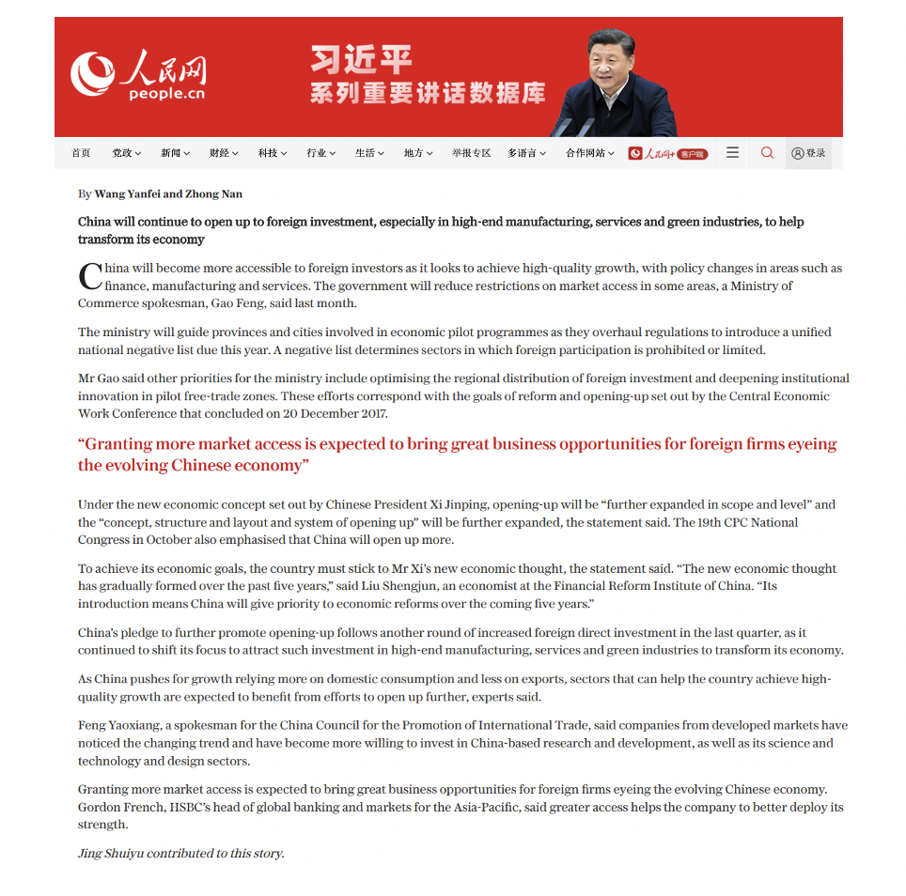

This control group was designed so as to compare *China Watch’s* efficacy in mediating American public opinion versus direct proclamations from the Chinese government itself. Logically, there would be little need for the Chinese Propaganda Department to disguise their native advertising propaganda as coming from a different source if a direct article released by the Chinese government had a greater effect on American attitudes. Of note, I decided not to make my control group one that featured an article unrelated to China. Although this might have been useful in certain regards, I decided that this style of control was ultimately unnecessary because of the design of my first treatment group, the New York Times Base group.

My first experimental group (New York Times Base) was exposed to a *China Watch* article edited so as to appear as if the article was solely written by *The* *New York Times* (NYT). This treatment group lacked the usual identification that normally would indicate that a *China Watch* article was written by and funded by the Chinese government (see appendix for treatment design). Instead, this treatment saw what appeared to be a pro-China news article written by the NYT staff. In this manner, I can interpret the results from my New York Times Base group as being indicative of how Americans’ attitudes about China are modified whenever they encounter a positive news article on China for a legacy media source.

My second experimental group (New York Times CW) received the same China Watch article in the same American media source as my NYT Base group, but it also included a large header indicating that the article was a *China Watch* article, a disclaimer that the article was written by and paid for the Chinese state, and a note that the NYT was not affiliated in any way with the writing of the article. This treatment was my first to include full identification and replication of a *China Watch* article as it would have appeared in American media outlets before being 2020. This treatment group was designed to answer one of my core research questions, what effect does exposure to identifiable Chinese foreign-facing propaganda have on American attitudes toward China and toward foreign policy regarding China?

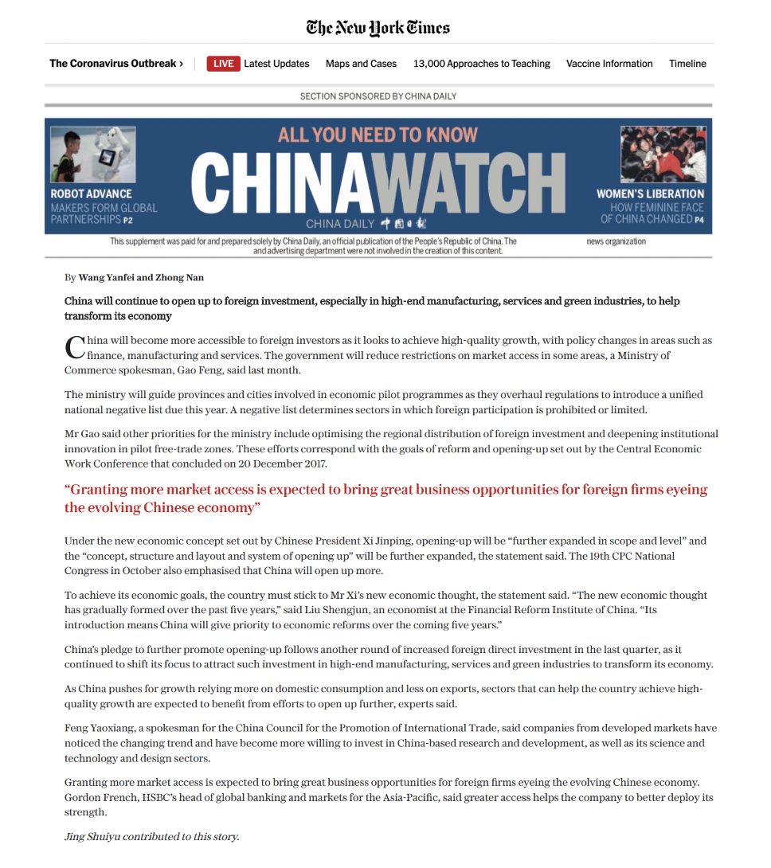

My third and fourth treatment groups were both variations of the NYT CW group. Treatment group three (Fox News CW) participants were shown the same image as NYT CW participants, but the header was edited so as to make it appear as if the *China Watch* article had appeared in a Fox News publication. Likewise, my fourth treatment group (Facebook CW) was similar in approach as the previous two but with edits to make it appear as if the *China Watch* article was featured on a Facebook user’s news feed. Both of these groups served the purpose of investigating hypotheses *(H3)* and *(H4)* and answering whether the identity of media source mattered in the overall outcome of changes in attitudes toward China.

Using this five-group experiment, I hope to gather results that will be able to differentiate between the mechanisms at play. For instance, if it turns out that the People’s Daily group had the least positive views of China after exposure, the NYT Base group had a slightly more negative views of China, and the NYT CW group had the most negative views, this would imply that something about knowledge that the Chinese government funded the article’s submission to the NYT led to the biggest change in attitudes. A non-significant statistical finding will require further discussion. In a case such as this, it is possible that Zaller’s theory of mass opinion and integrated threat theory worked opposite each other to cancel each other’s effects out.

***Data***

After treatment, participants answered survey questions about their reactions to the article they were exposed to, their attitudes toward China, and about thoughts on the media as well as their media viewing habits. Participants first answered questions about their attitudes toward China and their views on American foreign policy relating to China.

The first section of my survey after treatment was focused on gathering participant attitudes about the main dependent measures in this study, American attitudes about China and American foreign policy. The primary dependent measure was an attitudinal feeling thermometer on a 100-point scale. Participants were asked to rate how they felt toward China where higher numbers correlated to warmer feelings and vice versa. This dependent variable is a standard measure used in the study of public attitudes and foreign policy. After completing this primary attitudinal scale, participants were asked to complete an Osgood semantic differential scale where the opposing adjectives “untrustworthy” and “trustworthy” were placed at opposite ends of a 1 to 7 scale. Participants were asked to choose the number best represented which adjective they thought better described China. Participants were also asked to complete a scale ranking the amount of influence they thought China has in the world from 0 to 10 and to rate how they view China as a threat from “not an important threat at al all,” to “important but not critical threat,” to “critical threat.”

Next, participants were asked to respond to a series of policy preference questions on American foreign policy related to China. Respondents were asked to rate if they supported, opposed, or had no opinion on policy questions ranging from economic to security policy. These policy questions asked for participants views on American tariff, scientific research exchange, human rights, international development partnership, and South China Sea military policies. The last component of the Chinese-related dependent measures survey was to have participants complete an additional feeling thermometer on participants’ feelings about Chinese citizens, again on a scale of 0 to 100 with higher numbers correlating to warmer feelings. Generally speaking, people tend to have warmer feelings about foreign people than they do for foreign governments.

The second dependent measures survey section focused on participants’ reactions to the article they were exposed to and also their views on the media at-large. Participants were first asked to identify the media group which wrote the article they had just read. China Watch identified group participants were expected to correctly identify China Daily as the author of the article they had read while the New York Times Base and People’s Daily groups were supposed to identify each of those two sources, respectively, as being the authors of their assigned articles. Next, participants were asked to rate the trust they had in the accuracy of the article they had just read from 1 to 7, with 7 indicating complete trust. The next question was also on a 7-point scale by asked for participants to rate how convinced they were by the article they had just read with 7 indicating very convincing.

The following questions all asked participants’ media viewership habits as well as their beliefs about the media at-large. These dependent measures were largely adapted from pre-existing media scales that measure how much survey participants interact with the news. Participants were asked to give responses to questions asking how much news they read, listened to, or watched on average per day and how familiar they thought they were with the news. Participants were also asked a number of questions on their beliefs about the role of the news media in society and about their beliefs in media conspiracy theories. These questions included one that asked whether participants trust media organizations to report the news fairly, whether participants thought the media helps society solve problems, and whether participants thought the media actively lies in their reporting so as to benefit the rich and powerful. Lastly, participants were also asked to identify the source they turn to most often for news about the U.S. and the world: newspapers and news magazines, radio, network TV (like ABC, CBS), cable TV (like Fox News, MSNBC), blogs and other websites, or social media.

I also collected standard demographic information from my survey participants, including race, education, gender, age, income, and so forth. Collecting these demographic variables allowed for me to control for them in my analysis and to build the following simple model exploring how Americans’ attitudes toward China will change after exposure to Chinese propaganda:

Model 1

Two different models: regression with demographics; regression with demographics + media

Collecting dependent measures allowed for me to create a more complex model and control for media viewership habits:

Model 2

Overall, the simple model was more helpful than the complex model with demographic variables because, as my results section will show, there were not many statistically significant differences in attitudes toward China after exposure to the different treatments. In cases where there was variation between treatment groups, however, the extra media variables showed that Americans’ media consumption habits were often also significant in explaining why attitudes toward China shifted after exposure to Chinese propaganda. As it can be predicted, participants who spend more time watching and following the news were more likely to recognize that the article they were reading was written by the Chinese government and, subsequently, have more negative attitudes toward China. Interestingly, belief in media conspiracies also had the equivalent effect, suggesting that time spent watching media and overall distrust in media can serve as substitutes when mediating Americans’ attitudes toward China.

**Results**

***Attitudes Toward China***

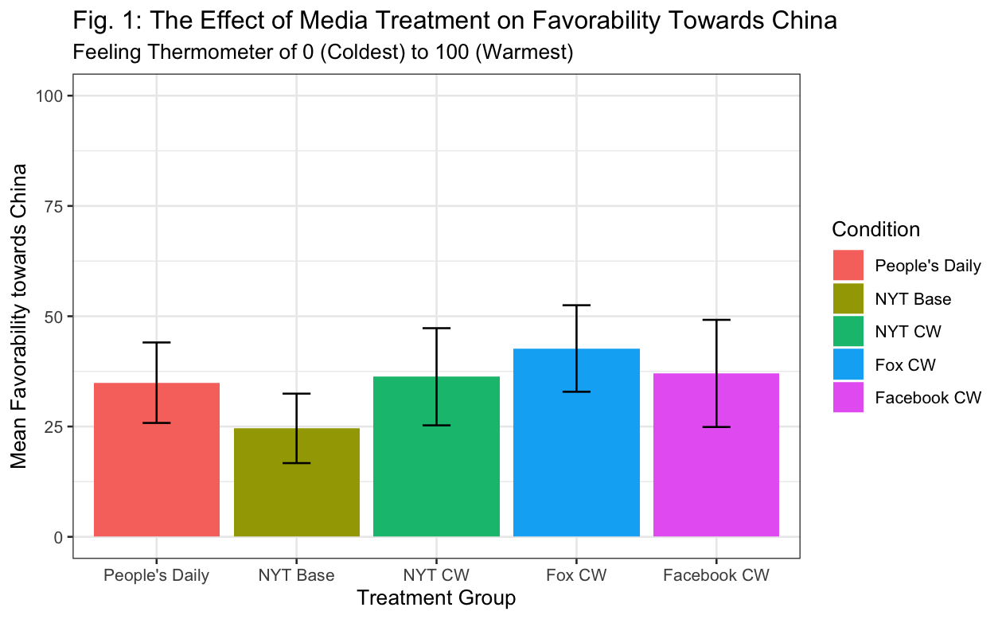

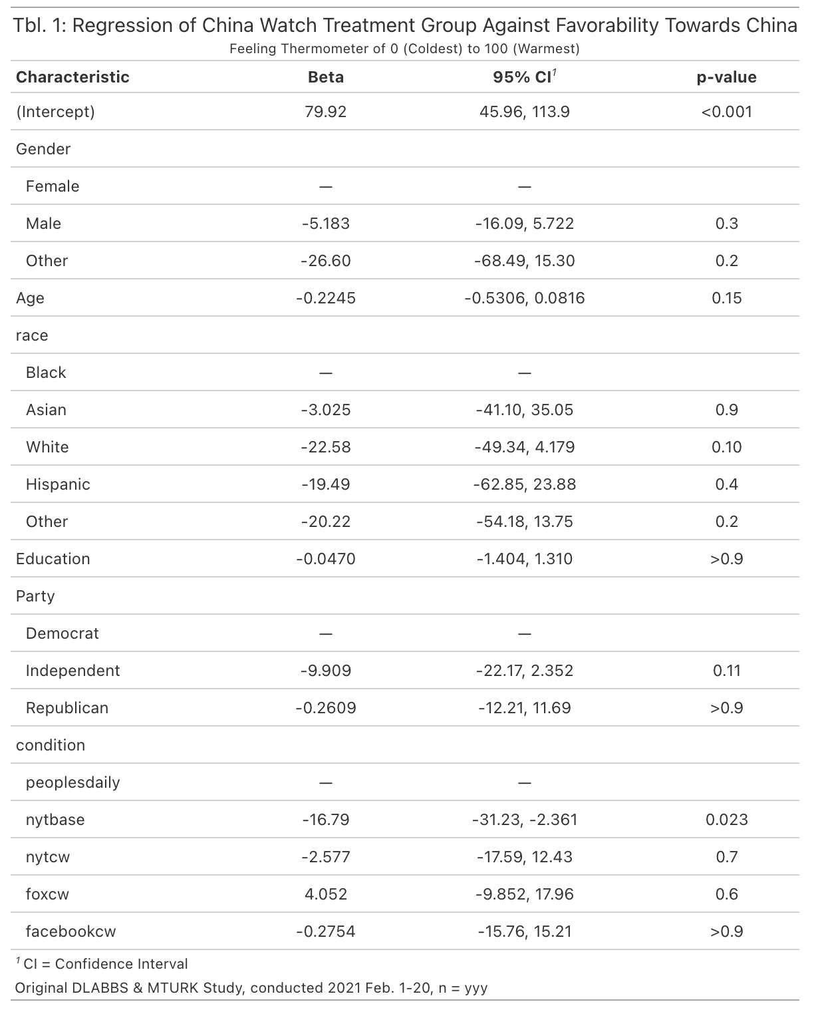

Contrary to what was predicted, participants exposed to labeled *China Watch* articles in the CW treatment groups did not have significantly colder feelings toward China as compared to the People’s Daily, direct CCP statement control group (peoplesdaily: *M*=34.93, *SD*=24.43; nytcw: *M*=36.28, *SD*=26.68; foxcw: *M*=42.69.; *SD*=27.20; facebookcw: *M*=37.04; *SD*=30.70). With this in mind, NYT Base group participants did have significantly colder feelings about China after exposure to a non-labeled, non-identifiable *China Watch* article (nytbase = *M*=24.58; *SD*=21.47), nytbase: p<.05. These results suggest contrary implications for my original hypotheses. First, I can confidently conclude that hypothesis *(H0), exposure to China Watch articles will actually depress American attitudes toward China as compared to non-camouflaged, direct communication from a Chinese source*, is false. As shown by a regression analysis on a feeling thermometer about China, exposure to direct contact with the CCP had the equivalent statistical effect on Americans’ attitudes toward China as exposure to clearly labeled *China Watch* articles, a version of Chinese external propaganda. These results do suggest, however, that hypothesis *(H1), exposure to labeled China Watch propaganda in a legacy media source like the New York Times, participants will interpret the greatest perception of threat from China and by extension have the least favorable attitudes to China*, is plausible. Of all my treatment groups, the NYT group participants had the lowest average attitude towards China with the NYT Base average being so much lower than the People’s Daily control so as to register as statistically significant.

After controlling for treatment, no demographic variables were found to have a significant causal effect on attitudes about China, even including political identification.

The surprising finding that Chinese external propaganda did no better than direct communication from the Chinese government suggests a few modifications to my existing theory. Evidently, Americans do not view too large of an intrinsic difference in communication that comes from the Chinese government itself and that which is routed through a third-party media source. What was perhaps even more surprising though was that the People’s Daily and China Watch groups all had significantly more favorable opinions of China than did the NYT Base group. Because NYT Base group participants were given no information indicating that the article they had read was written by the Chinese government until the end-of-experiment debriefing, it cannot be the case that these NYT Base participants knew that they were being exposed to Chinese propaganda. Therefore, one can interpret the results of this group as being equivalent to if participants had read a positive article about China that was actually written and published by the NYT. Since the NYT Base group lead to significantly less favorable attitudes than did all other groups, this implies that China’s *China Watch* campaign actually *did* have a positive effect on Americans attitudes about China, at least compared to standard American reporting on the country.

This result is astounding. Keep in mind that the NYT Base group featured an intrinsically biased article that was very favorable in its coverage of China. Given that most American media coverage on China has recently focused on negative aspects of the country—including deteriorating U.S.-China relations, human rights violations, an increasingly authoritarian Chinese government, and the cryptic origins of the COVID-19—it makes sense to assume that a random *NYT* article about China might actually lead to even less favorable views of the country as the NYT Base group registered. A number of potential mechanisms could account for this result. First, it is very possible that my original integrated threat theory mechanism still drives this trend, although albeit at a much stronger level than originally hypothesized. That is, Americans rationally view Chinese outreach as a legitimate and costly signal that China wants to establish warmer relations with the United States. Such outreach is seen as persuasive, leading Americans to downgrade their prior beliefs about Chinese threat and thereby increasing favorability towards China. Alternatively, it is possible that something about the NYT Base treatment itself made participants more wary of China than in the other treatment groups. For instance, participants could be so primed to view negative reporting on China from American news sources, or so distrusting of legacy news sources, that they interpret objectively positive news coverage flawed and, perhaps, even negative in nature. If this is the case, there should be a difference in results after controlling for participants’ trust in the media and amount of time spent watching news. I test for this theory by controlling for media interaction trends.

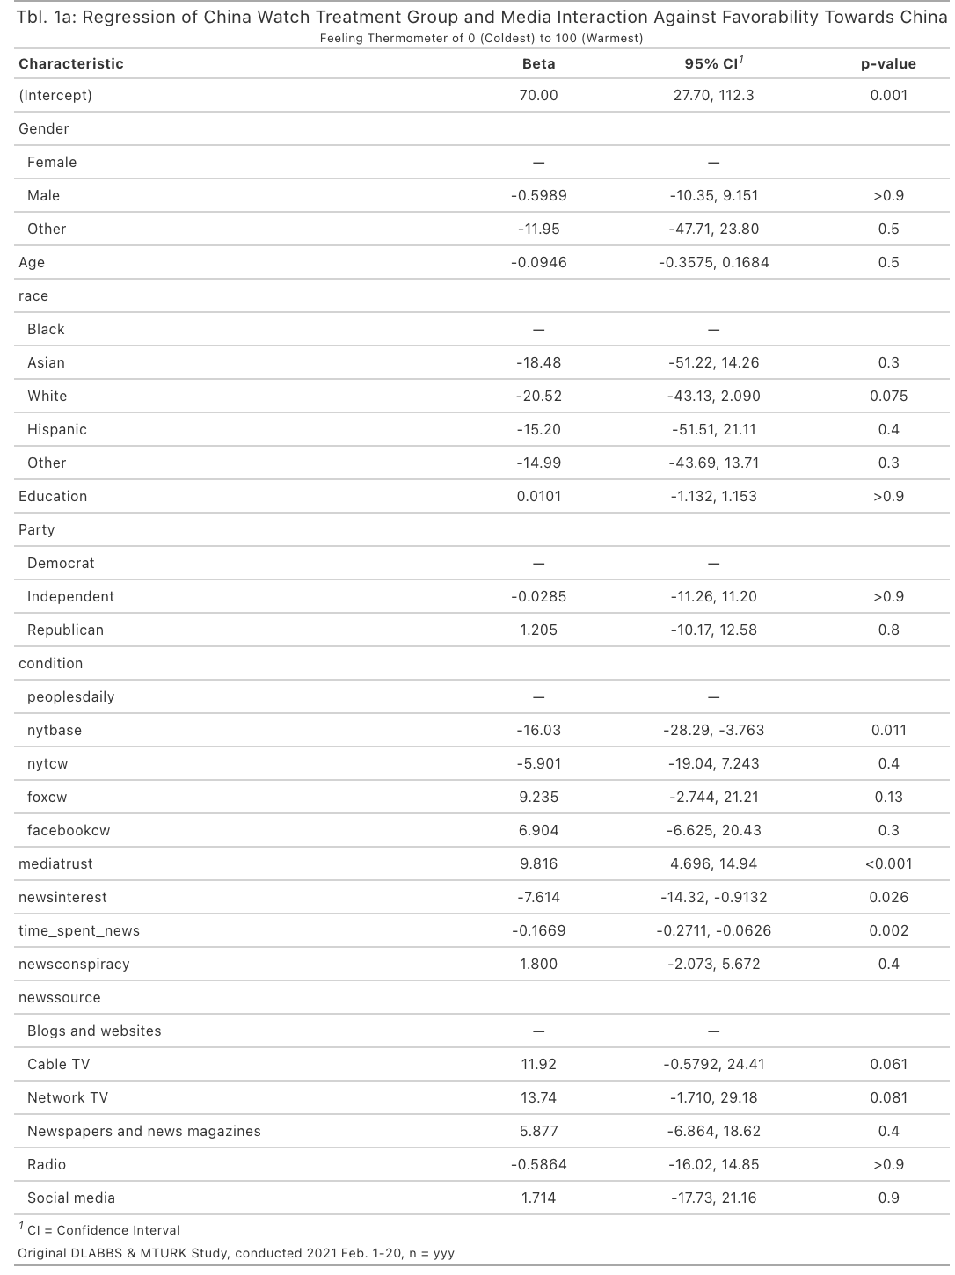

Controlling for media interaction independent measures shows that the NYT Base treatment still leads participants to assign significantly less favorable opinions of China as compared to other experimental groups, even the NYT CW group. Moreover, trust in the media, interest in the news, and time spent watching the news are all significantly in causally affecting people’s attitudes about China after exposure to my experimental treatment (mediatrust: p<.05; newsinterest: p<.05; time_spent_news: p <.05). Notably, having more trust in the media lead to more positive assessments of China after treatment. More interest in the news and more time spent watching the news per day were associated with more negative assessments of China after treatment. Granted, it is possible there was a definitional difference that led to these outcomes—certain people may interpret the word “media” to only relate to legacy media organizations like the NYT and to not cover more modern media organizations like Fox News or social media.

These findings suggest that Americans’ media consumption habits have a significant effect on how Americans interact with the news and how they then translate media information into salient policy preferences and views on the political world around them. Moreover, the opposite valanced effects of the trust in media variable and news interest variable suggest that there are two different types of participants in my survey—people who are very interested in the news but often do not trust certain media outlets and people who generally trust the news media but do not believe the news to be one of their major interests, even though they still follow it. These two classes of American media consumers might then react to the news differently. The low-trust, high-interest consumers might assign a similar amount of trust to standard reporting by legacy media outlets like the *NYT* as they do to articles written by the CCP, limiting the amount of persuasion that can be conveyed by NYT reporting by not limiting the amount of persuasion that can be conveyed by other media outlets or Chinese propaganda itself. On the other hand, the high-trust, low-interest consumers might assign so much trust to American media outlets that they take what newspapers publish at face value, including Chinese propaganda, but they lack the intrinsic motivation and interest in news to be persuaded by news articles. These two mechanisms might therefore help explain why American attitudes toward China seem to be least favorable after exposure to the NYT Base and NYT CW groups through an explanation of motivated reasoning—a subset of Americans so avidly distrusts NYT reporting that they interpret positive articles as conveying negative information about the topic at-hand. Meanwhile, another subset of Americans may trust legacy media reporting, but they lack the interest to become persuaded by media coverage, leaving their policy preferences and attitudes about politics to be stable even after exposure.

This measurement variable also confirmed hypotheses (*H3), exposure to China Watch propaganda will lead to different effects depending on the media source in which individuals saw China Watch placed in,* and (*H4,) Americans will assign more negative attitudes toward China after exposure to China Watch articles located in legacy media sources as compared to China Watch articles located in non-legacy media sources*.

Lastly, while these results are surprising, it should be noted that no group had a positive view of China. All 5 experimental groups had mean feeling thermometer ratings much less than 50 out of 100, meaning that all groups viewed China unfavorably, although some more than others.

***Perceived Trustworthiness of China***

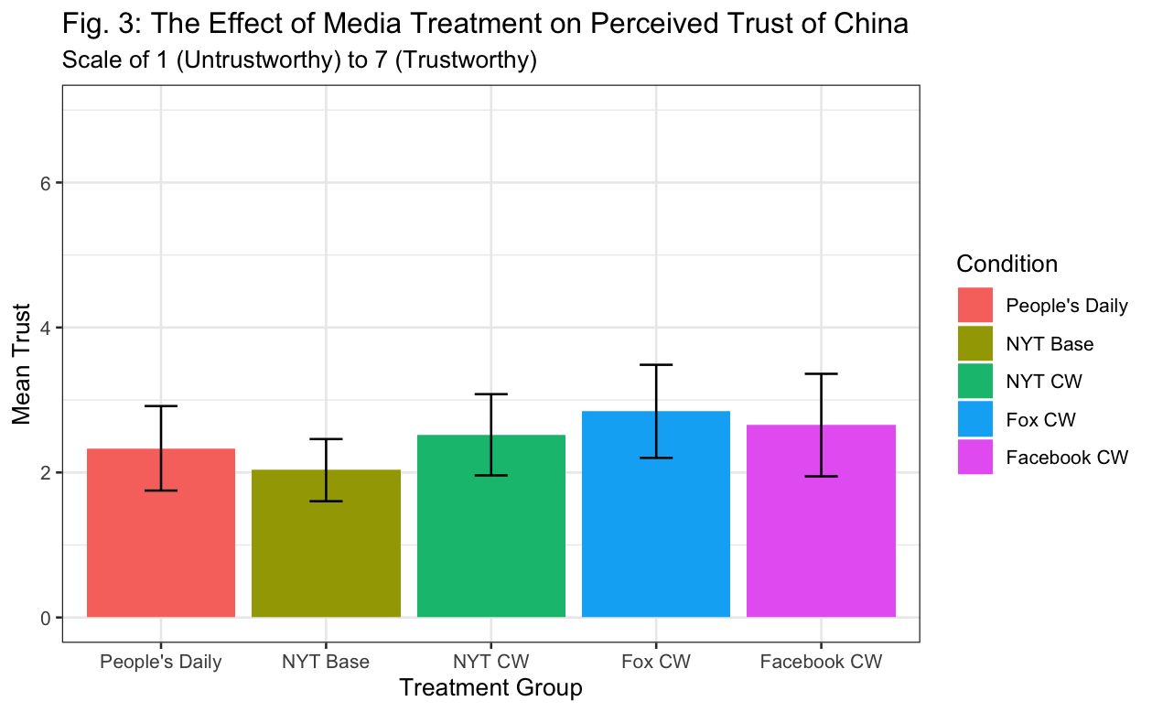

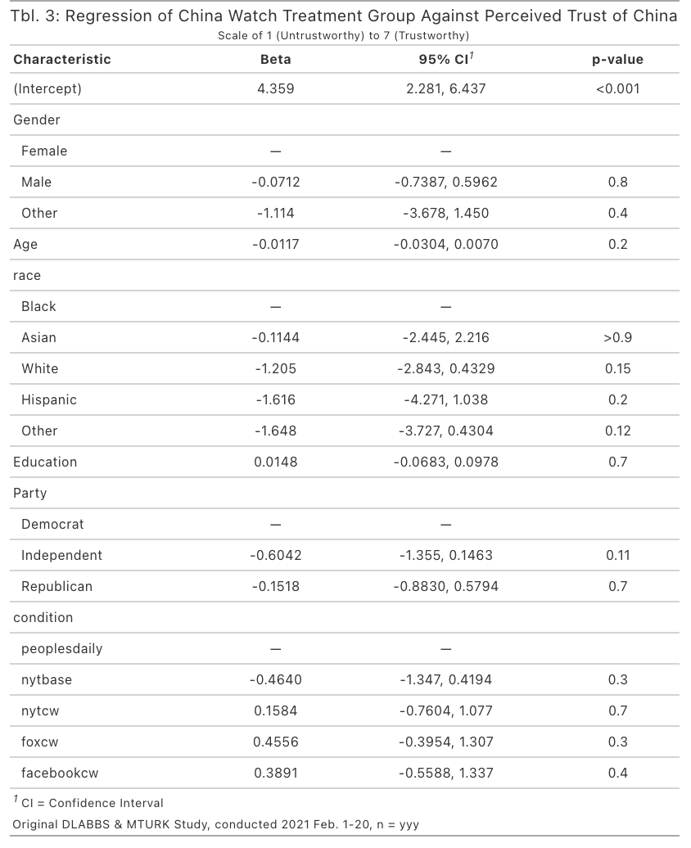

Treatment group assignment appeared to have no significant effect on people’s perceived trustworthiness of China (peoplesdaily: *M*=2.33, *SD*=1.56; nytbase = *M*=2.03; *SD*=1.17; nytcw: *M*=2.52, *SD*=1.36; foxcw: *M*=2.84.; *SD*=1.78; facebookcw: *M*=2.65; *SD*=1.79). All of these mean ratings were below the halfway mark of the scale indicating that all groups inherently think of China as being untrustworthy.

After controlling for treatment, I found that no demographic variable was causally related to participants’ perceived trustworthiness of China. Evidently, if a main goal for the *China Watch* propaganda program is to convince Americans that China is a trustworthy state that the U.S. can cooperate it, then the *China Watch* program has not satisfied it. Americans views on the trustworthiness of China in the international arena seems to be stable across numerous variables.

***Perceived Influence of China in the World***

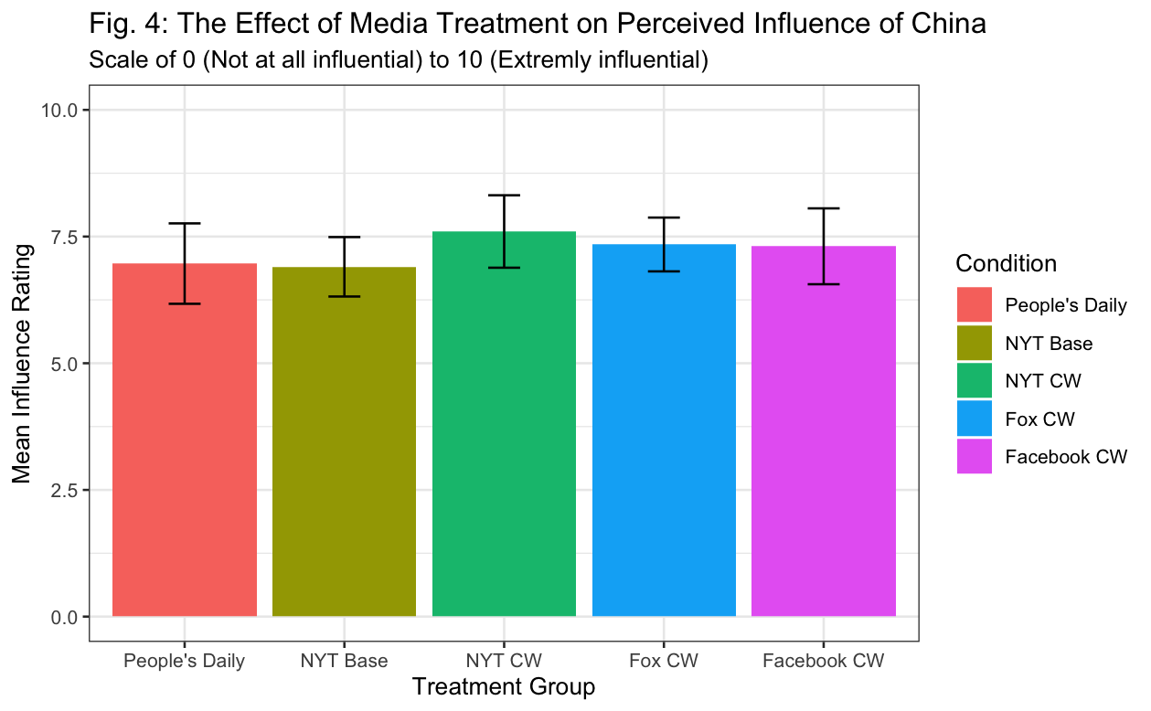

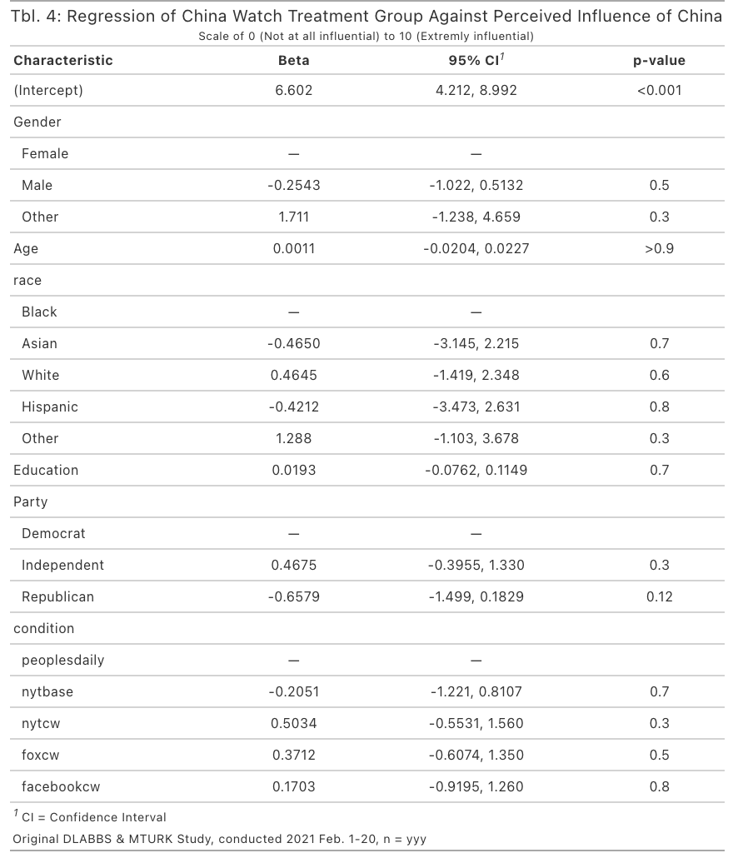

Equivalent to the previous measurement on perceptions of China’s trustworthiness, treatment group assignment appeared to have no significant effect on people’s perception of China’s influence in the world (peoplesdaily: *M*=6.97, *SD*=2.13; nytbase = *M*=6.90; *SD*=1.60; nytcw: *M*=7.6, *SD*=1.73; foxcw: *M*=7.34.; *SD*=1.48; facebookcw: *M*=7.31; *SD*=1.89). All groups viewed China as being influential in the world, although groups who were exposed to labeled *China Watch* articles thought China was slightly more influential. This minimal effect was likely due to CW group participants adjusting their assessments of Chinese influence upwards after viewing Chinese propaganda in leading American media outlets.

Much like the previous measurement, no demographic variables were found to have an effect on the measurement. Americans views on China’s influence in the international arena appear to be stable across multiple variables.

***Perception of China’s Threat to American Interests***

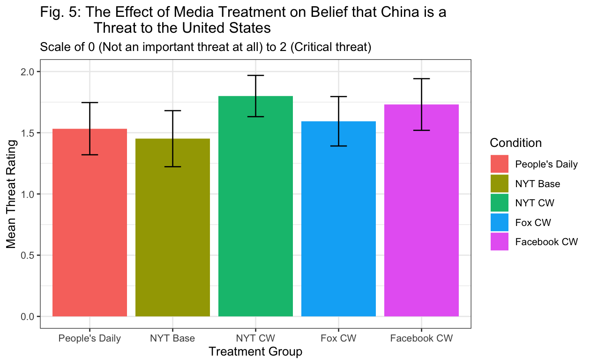

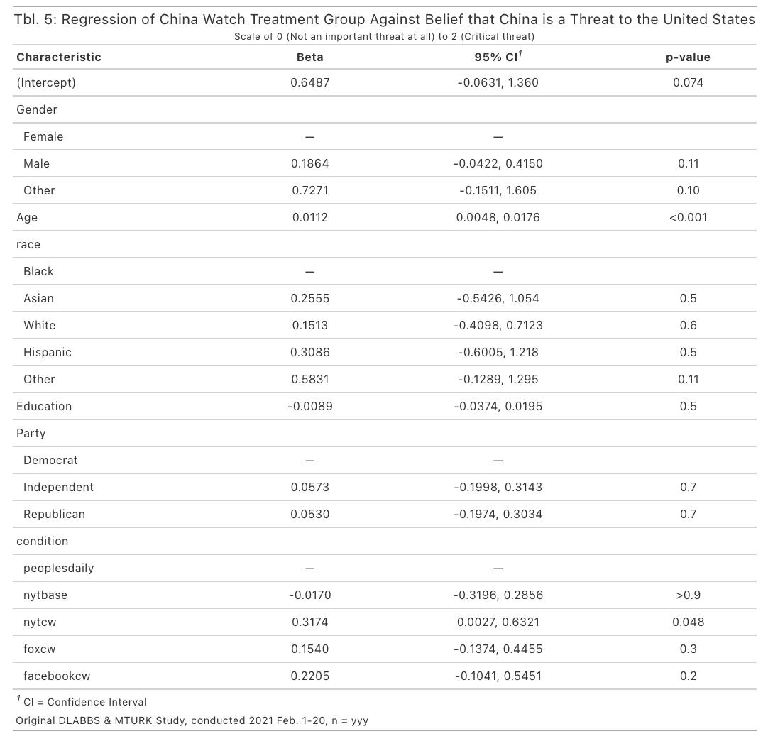

Unlike measurements of participants’ perceptions of China’s trustworthiness and influence, the NYT CW treatment group assignment appeared to have a significant effect on participant attitudes toward Chinese citizens, making participants interpret China as posing a more critical threat to American interests (nytcw: *M*=7.6, *SD*=1.73), p<.05. None of the other treatment groups showed significant results, although all three of the CW treatments, including the Fox CW and Facebook CW treatments, led participants to rate China as posing a larger threat to the U.S. (peoplesdaily: *M*=1.53, *SD*=0.57; nytbase = *M*=1.45; *SD*=0.62; foxcw: *M*=1.59.; *SD*=0.56; facebookcw: *M*=1.73; *SD*=0.53).

This outcome variable is especially important due to the emergence of a “China threat theory” in the international relations literature that posits China will become increasingly hostile to the U.S. and U.S.-allied countries as its own power grows (Broomfield. 2010). As this outcome shows, all treatment groups viewed China as posing a threat to American interests, but the participants groups exposed to CW treatments—those with a *China Watch* article labeled as being funded by the Chinese government—perceived China as posing a more “critical” threat to American interests. This effect dovetails with integrated threat theory and is likely due to people’s rational interpretation of a real threat—if a foreign government has the means to pay for and place propaganda in the U.S.’s domestic media outlets, they must have some capability to compete with the United States in global affairs.

After controlling for treatment groups, the only demographic variable that had a significant effect on this outcome variable was age (p<.01). Previous literature has shown that older people tend to be more conservative than youth and that older people tend to less open to new experiences (Cornelis et al., 2008).

***Attitudes toward Participants’ Treatment Articles – Trust and Persuasion***

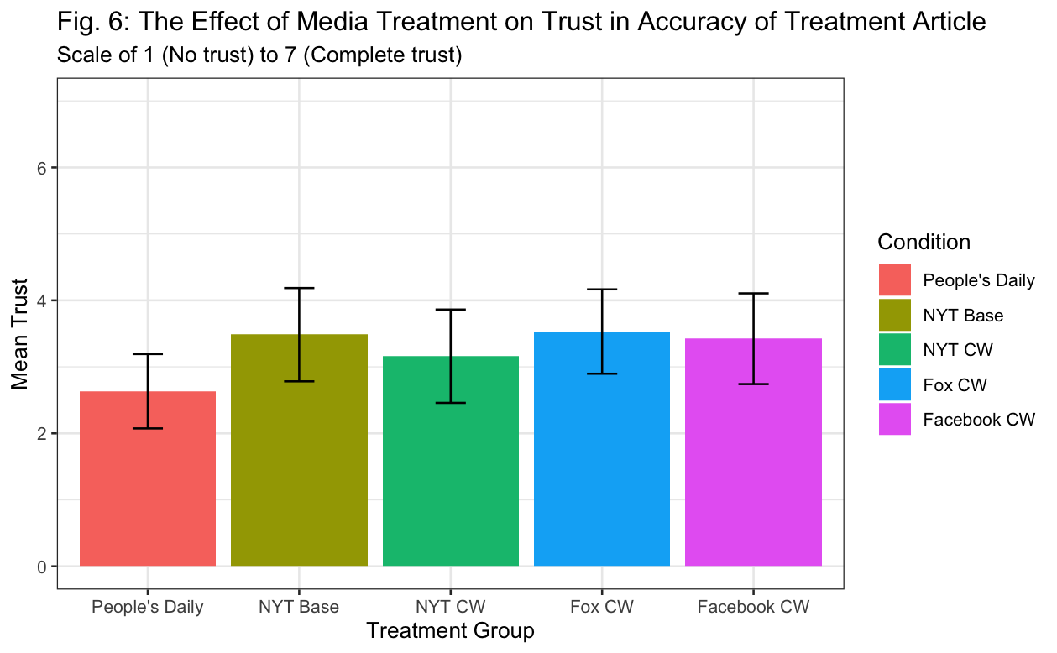

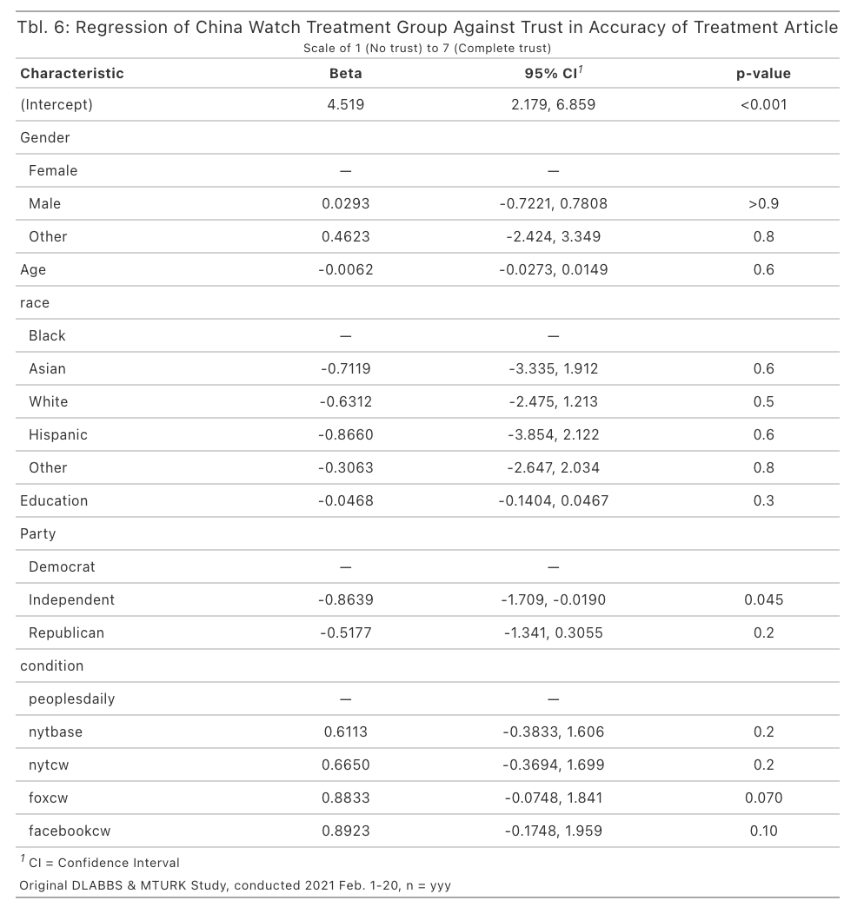

In the simple model considering treatment and demographics alone, treatment did not appear to have significant influence over participants’ perceptions of their article’s trustworthiness and persuasiveness. When evaluating effects using the media interaction model, however, treatment groups were shown to be significant. Take, for example, participants’ perceptions of the accuracy and factualness of the identical article they read across treatment. No article was seen as being more accurate, even comparing the *People’s Daily* version of the article to the *NYT* base version, with both lacking any identifying information that the assigned article as a piece of Chinese external propaganda (peoplesdaily: *M*=2.63, *SD*=1.50; nytbase = *M*=3.48; *SD*=1.91; nytcw: *M*=3.16, *SD*=1.70; foxcw: *M*=3.53.; *SD*=1.76; facebookcw: *M*=3.42; *SD*=1.72). Furthermore, political identification was the only significant demographic variable, Independent: p<.05.

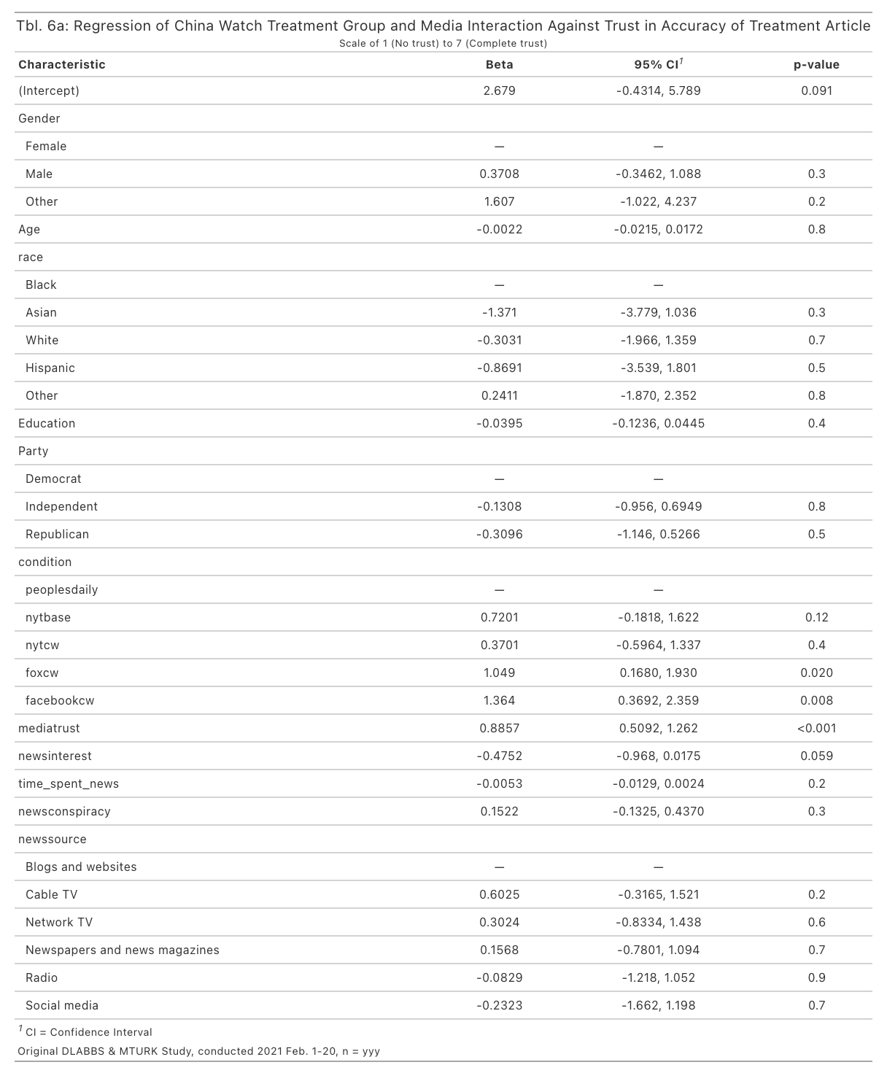

After controlling for media interaction variables in addition to demographics and treatment group, however, I found that there were a number of changes in explanatory power. Controlling for media interaction reduced the power that political identification had in previously explaining my results and made it so that only trust in media had a significant effect in explaining the level of trust people assigned to the articles they had just read, mediatrust: p<.05. Furthermore, adding media interaction variables gave significance to the Fox CW and Facebook CW groups; foxcw: p<.05, facebookcw: p<.01. This change in significance indicates that there is something specific to these two groups that my media related variables did not capture. I believe the most likely distinction is because these two groups locate the *China Watch* article in more modern media outlets that most consider distinct from legacy media. Therefore, traditional questions that ask about people’s trust in the media might not accurately capture their feelings about these other non-legacy sources of media.

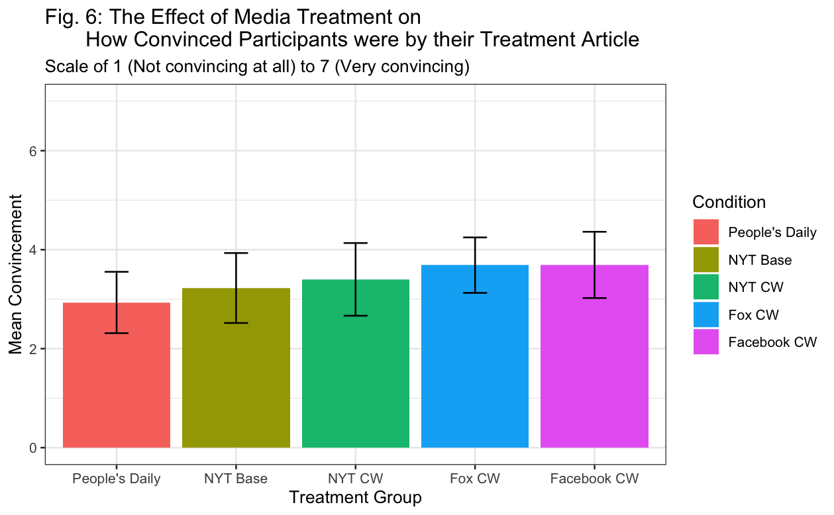

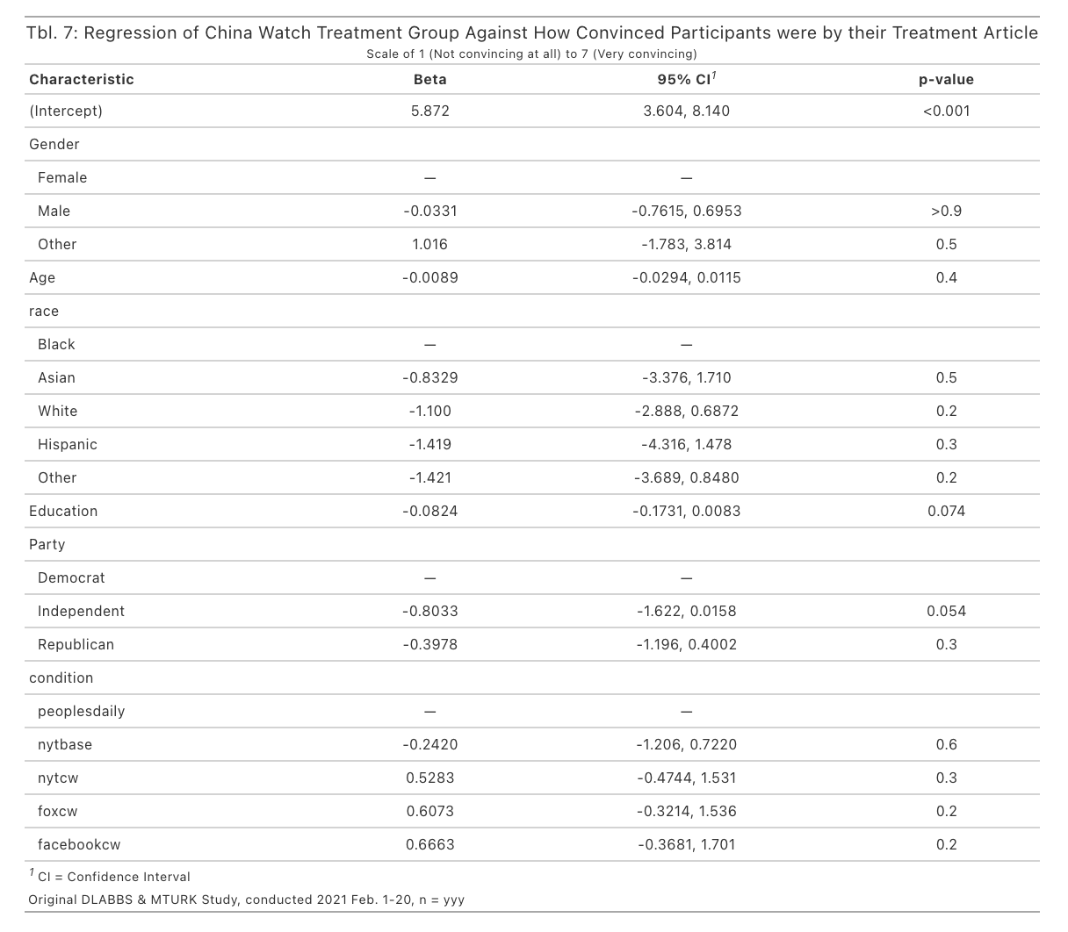

The trends with an outcome variable on self-identified persuasion was similar in that no treatment showed significance in the simple, demographics-only model (peoplesdaily: *M*=2.93, *SD*=1.66; nytbase = *M*=3.23; *SD*=1.93; nytcw: *M*=3.40, *SD*=1.78; foxcw: *M*=3.69.; *SD*=1.55; facebookcw: *M*=3.69; *SD*=1.69). Furthermore, no demographic variables were significant.

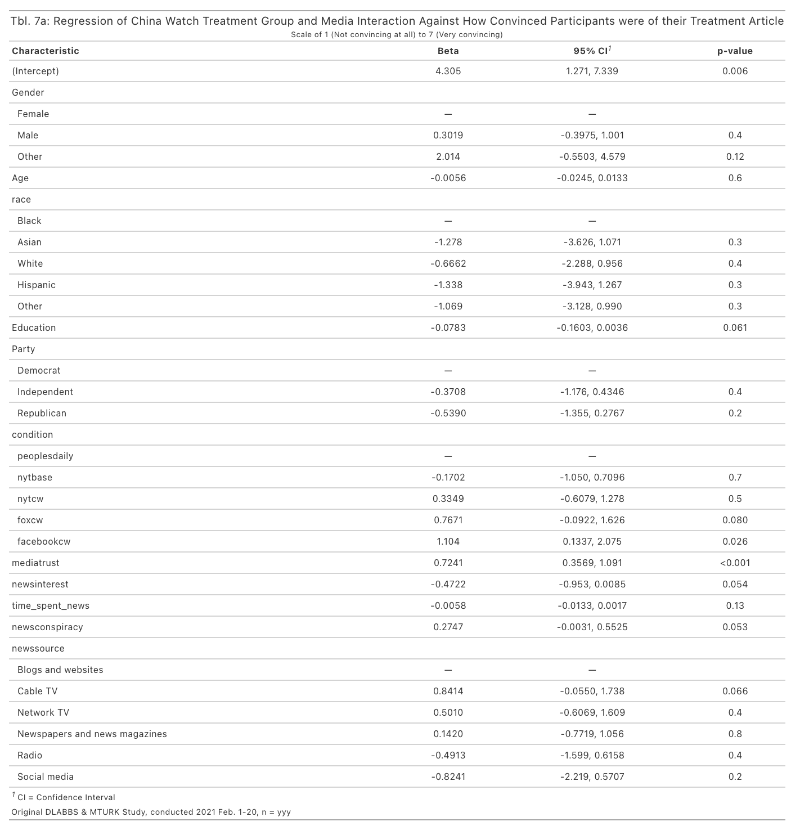

After adding media interaction variables into the model, results were modified in a similar way as with the article trust outcome. Once again, the only ancillary variable with statistical significance was trust in media, mediatrust: p<.01. Once again, the Facebook CW treatment was significant, although not the Fox CW treatment, facebookcw: p<.05.

Overall, no treatment group found their assigned article to be particularly convincing or trustworthy. This finding makes sense as the overall favorability rating to China as captured by a feeling thermometer showed that four of the five treatments led to similar views on China with only the NYT Base group leading to significantly colder views. It should be noted that the NYT Base group did register the highest average trust rating out of all the groups, although it simultaneously had the lowest persuasion rating as well. Evidently, participants thought they were not particularly swayed by any of their treatments, a conclusion verified by the limited variation between treatment groups seen in the overall favorability measurement. An overall perplexing finding, though, is why assigned trust to an apparent *NYT* article was not significantly higher than that given to Chinese propaganda or a direct article from the Chinese government itself. I tentatively hypothesize that either participants in the NYT Base group somehow identified the article as not being truly written by the *NYT*, or otherwise that the online survey population I sampled from for this study was biased in some way against legacy media outlets like the *NYT*.

***Policy Positions***

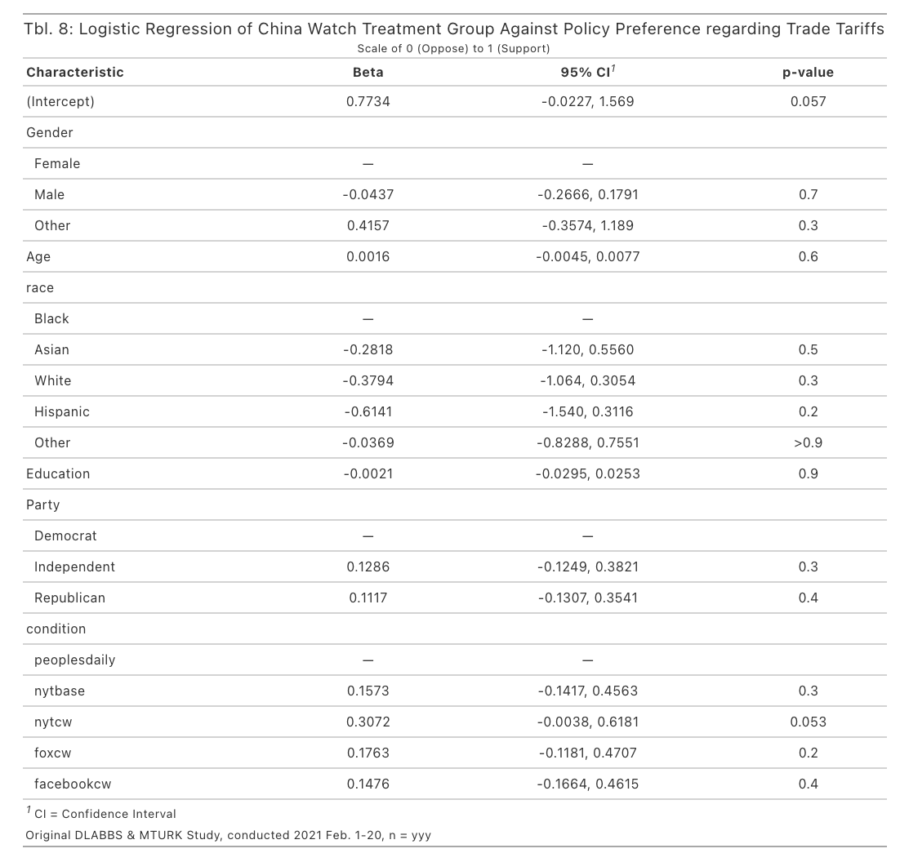

Results generally held steady across policy preference questions, as measured by logistic regression analysis. In the majority of policy questions, Americans supported the anti-China policy choice, such as in imposing tariffs on Chinese imports. There was often no differentiation in attitudes depending on whether participants read an article edited to appear as if it originated from the Chinese government itself, from a legacy American newspaper like the *NYT*, or from an identifiable *China Watch* propaganda article.

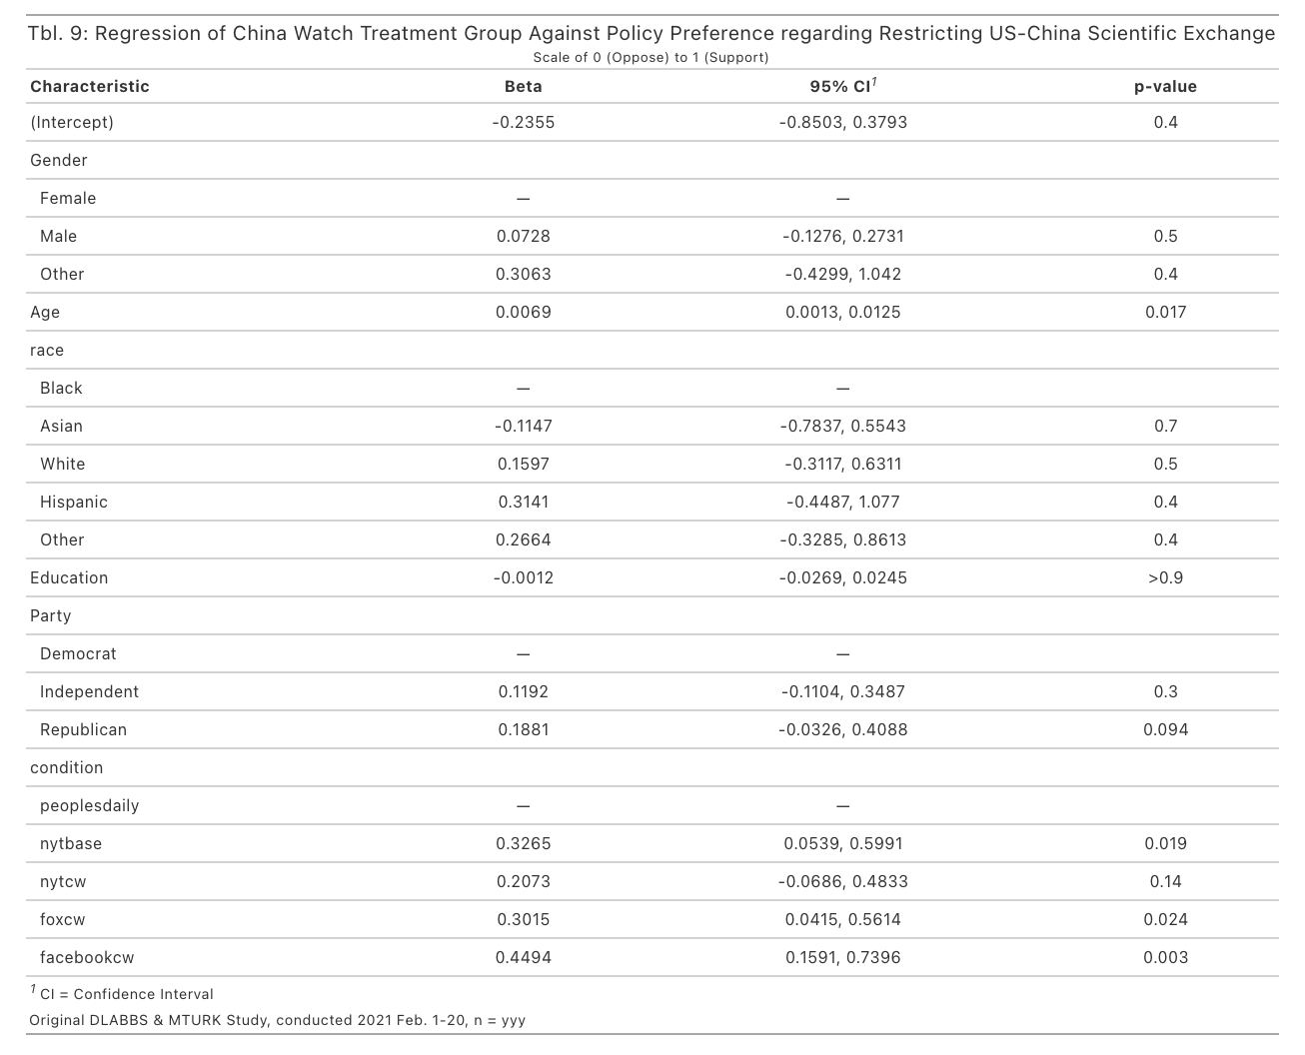

With this said, there was some divergence from the general pattern when I asked for policy preferences explicitly asking about Sino-American cooperation. In these questions, Americans supported cooperation more directly when exposed direct communication from the Chinese government supporting Chinese cooperation with the international community, such as into the People’s Daily control. One example of this type of result was found in a question asking participants to weigh in on Sino-American scientific exchange. Compared to the People’s Daily control, the NYT Base, Fox CW, and Facebook CW treatments all had significant effects on participants’ policy preference, switching the average preference in each group from supporting scientific exchange (cooperative) to placing restrictions on it (non-cooperative),

***Trust***

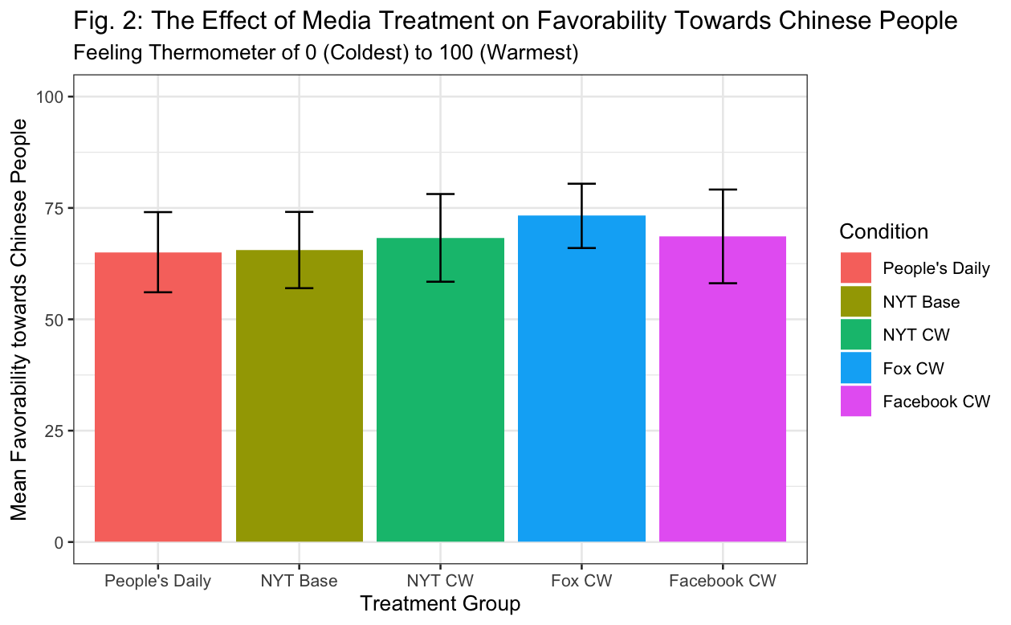

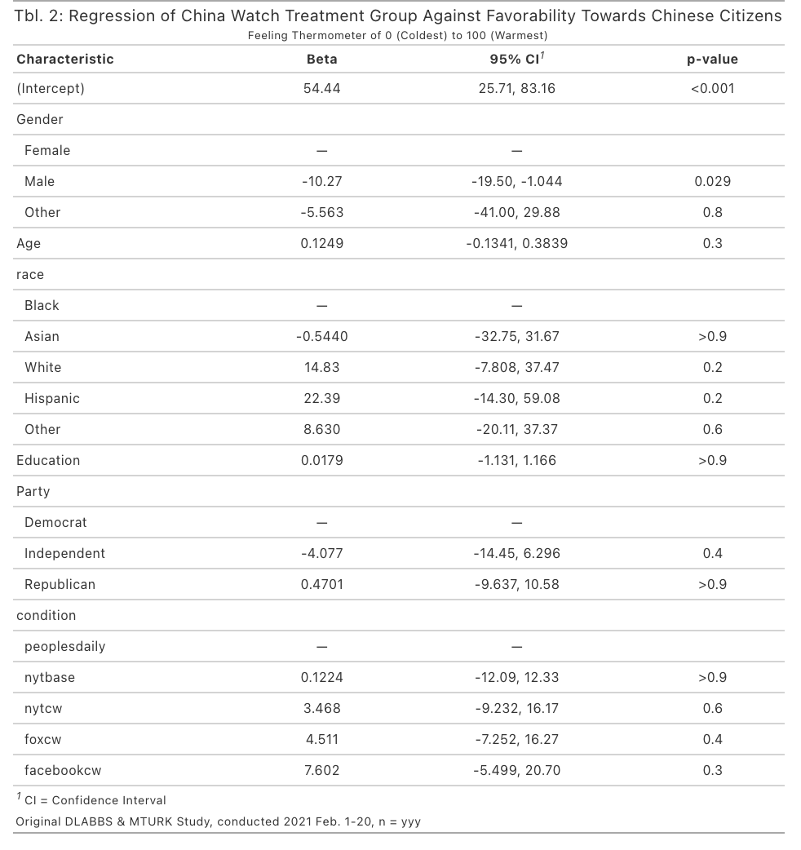

Unlike favorability towards China in general, none of the treatment groups had any significant effect on participant attitudes toward Chinese citizens (peoplesdaily: *M*=65.07, *SD*=24.10; nytbase: *M*=65.55, *SD*=23.34; nytcw: *M*=68.28, *SD*=23.85; foxcw: *M*=73.22, *SD*=20.03; facebookcw: *M*=68.62, *SD*=26.59). As expected, when comparing within the same treatment group, the mean favorability ratings toward Chinese citizens were also all higher than the mean favorability ratings toward China in general.

After controlling for treatment groups, the only demographic variable that had a significant effect on participant attitudes toward Chinese citizens was gender (p<.05).

**Study 2:**

**Research Design**

1. *Design and Hypothesis*

To test whether direct exposure to Chinese media or Chinese statements are always effective in modifying public opinion about China, I also ran a quick study exposing participants to either one of two quotes from Chinese President Xi Jinping. In recent years, Xi has been appealing to ethnic Chinese living abroad to further support China in international and current affairs. I hypothesized that this sort of explicit outreach would be looked upon unfavorably by most Americans and lead to Americans labeling ethnic Chinese, including Chinese Americans, as potential security threats, thereby exacerbating ethnic tension in the United States. I tested for this hypothesis in a simple experiment that exposed participants to one of two quotes from Xi Jinping.

The first quote relates to the CCP’s campaign to have ethnic Chinese abroad interface more with their local communities with pro-China pride. The relevant quote was taken from Xi’s report to the 19th Party Congress in October 2017.

“We must conscientiously safeguard the solidarity and unity of the Party,

maintain the Party’s deep bond with the people, and strengthen the great unity of

the Chinese people of all ethnic groups and the great unity of all the sons and

daughters of the Chinese nation at home and abroad. We must unite all the forces

that can be united and work as one to progress toward the brilliant future of

national rejuvenation.”

(“全党一定要自觉维护党的团结统一，保持党同人民群众的血肉联系，巩固全国各族人民大团结，加强海内外中华儿女大团结，团结一切可以团结的力量，齐心协力走向中华民族伟大复兴的光明前景。”)

The second quote was taken from a 2012 speech from Xi when he first assumed office as China’s president.

"Corruption could lead to the collapse of the Party and the downfall of the state."

I randomly assigned participants to one of the two treatments and then followed up by asking three questions, each on their perspectives of Chinese Americans and Chinese immigrants. The first question I asked was whether participants thought, when it comes to economic issues between the United States and China, did they think Chinese Americans are more likely to support the U.S. or China. The second question was identical but asked about military issues rather than economic issues. The third question focused on academia and scientific research, asking whether participants thought that Chinese immigrants and Chinese Americans who work for the U.S. government and U.S. companies as researchers, scientists, and engineers pose a security risk to the U.S.

**Results**

***Attitudes Toward China***

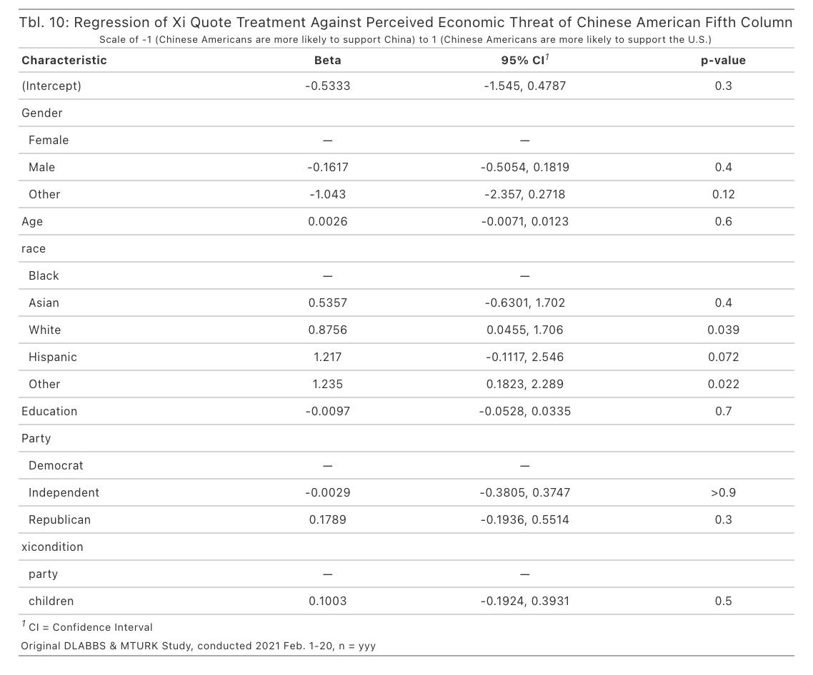

Participants views on the potential economic threat that Chinese Americans pose to American interests did not differ between groups (above). However, views did differ after treatment when it came to military issues. Moreover, when examining mean attitudes of this question compared to participants’ original treatment in study 1, it was evident that direct communication from the Chinese government as via *People’s Daily* and also identifiable Chinese propaganda via *China Watch* led to a higher average assessment of the “threat” Chinese Americans will side with China during military conflict (peoplesdaily: *M*=0.50, *SD*=0.73; nytbase: *M*=0.19, *SD*=0.91; nytcw: *M*=0.28, *SD*=0.84; foxcw: *M*=0.47, *SD*=0.84; facebookcw: *M*=0.31, *SD*=0.88). This finding is concerning. False concerns of ethnic fifth columns in the United States have previously led to serve deprivation of civil and human rights, as when the American government interned Japanese Americans from 1942-1944 due to the Second World War.

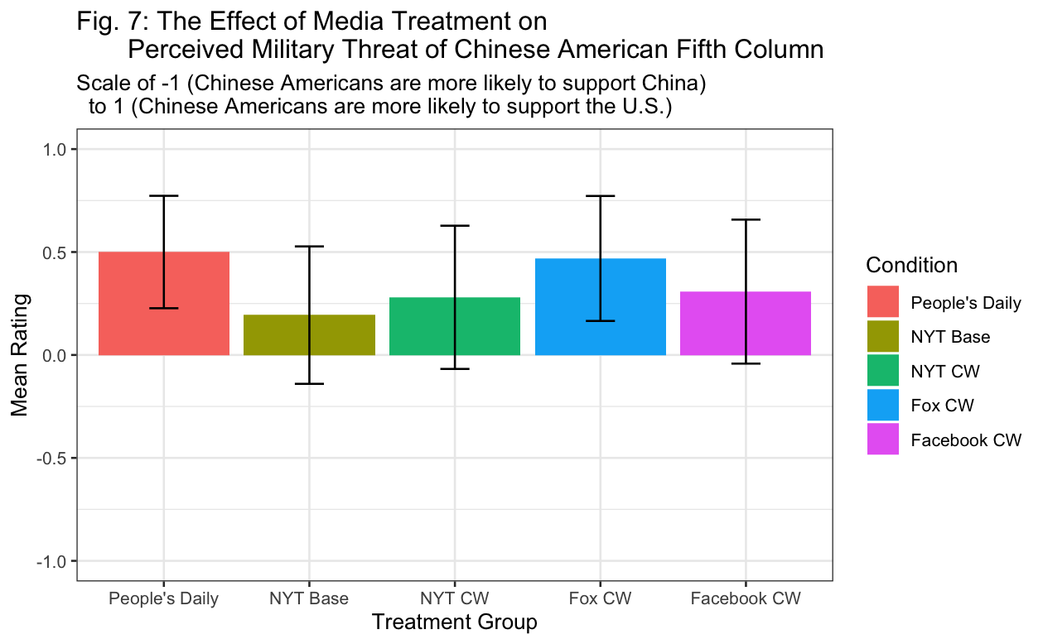

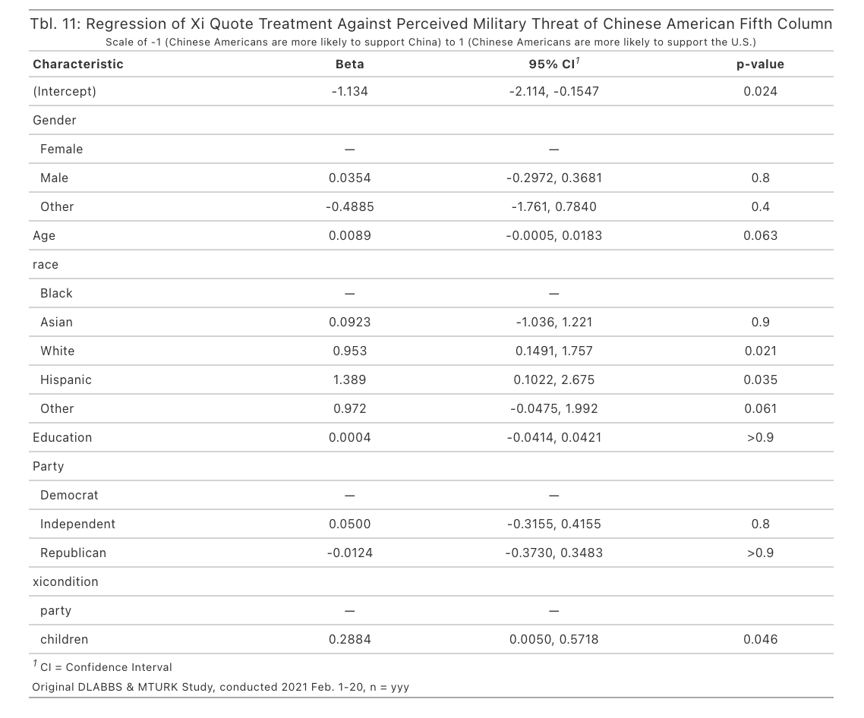

As previously mentioned, the treatment had a significant effect on participants views, with participants receiving Xi’s quote on the “children of China” more likely to indicate that Chinese Americans will support China to a greater extent than they do the United States in military matters.

After controlling for treatment, the only demographic variable that had a significant effect on participant attitudes was race, with Hispanic and White respondents more likely to say Chinese Americans would side with China rather than the U.S., white: p<.05; Hispanic: p<.05.

**General Discussion**

In this chapter, I provide original data on how interaction with pro-China, Chinese propaganda can have counterintuitive effects on Americans attitudes toward China. Convergent results across multiple dependent measures showed that after exposure to labeled *China Watch* articles, participants do not have significantly more warmer attitudes about China as compared to direct communication from the Chinese government itself (Tbl. 1, Tbl. 2, Tbl. 3). Furthermore, the media outlet that *China Watch* articles were placed in did not have a significant effect on reversing this trend, although respondents tended to react most negatively to news reporting from the *NYT* as compared to Fox News or social media. These findings were robust across a number of measures, including policy preferences regarding interaction with China and Americans’ perceived influence and trustworthiness of China on the world stage.

Much has been written about the efforts that the Chinese government has gone to soften their image among the international public. This study provides evidence that continued funding of external facing propaganda campaigns like *China Watch* may be having limited rates of return. For instance, participants who were exposed to the identifiable, most close to reality version of *China Watch* (CW groups) rated China as posing more of a critical risk to American interests than did other treatment groups (Tbl. 4, Fig. 4). This finding suggests that the Chinese state might want to pursue other avenues in which to interact and engage with the American public.

A potential concern with this experiment is that participants might have been that a survey experiment does not readily replicate the real-world experience of interacting with camouflaged Chinese propaganda. Therefore, participants might not have been sufficiently deceived by my experimental design. I argue, however, that this concern should not be too troubling and that my design shows the strength of the existing trends after exposure. Even in a controlled setting, where participants had no task besides reading a piece of Chinese propaganda and no distractions to deter them from doing so, propaganda was found to have no effect on attitudes as compared to direct marketing from the Chinese government. In the real-world, it is unlikely that participants fully commit to reading these articles and engage in the cognitive processes necessary to change attitudes, a process my experiment was explicitly designed to stimulate. Another potential concern was that participants did not sufficiently recognize which treatment group they were involved in and assigned writing of their article to incorrect sources. As the following figure shows, though, the vast majority of participants were able to correctly identify the media outlet who had written the article they were exposed to.

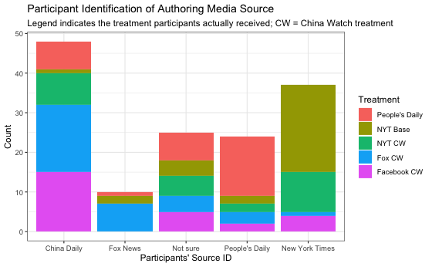

Overall, it remains unclear as to what mechanisms were influencing the lack of change in attitudes. I suspect that there are at least a few potential mechanisms involved. With this in mind, however, I believe the bulk of evidence points to experimental participants processing their exposure to *China Watch* through an integrated threat model, evaluating China in terms of symbolic and real risks. In instances where participants were given good reason to upgrade their perceived risk of China, such as when the *NYT* “published” a story about the economic connections of China’s financial system to Western financial systems (NYT Base), attitudes toward China decreased. When participants saw communication from China that indicated a willingness to engage in cooperation, such as in the People’s Daily control group, they downgraded or kept their risk perceptions of China the same, keeping attitude warmer towards China than in the NYT Base scenario. This model of *China Watch* holds the greatest amount of evidence. Based on participants’ self-reporting on how trustworthy they thought the articles they read were and how convincing they were, I doubt persuasion happened to the degree necessary for the Zaller model of informed public opinion change to occur in full.

To my knowledge, there has been only one previous experiment that analyzed how Chinese external propaganda interacts with an international experiment, but this previous experiment did not measure attitudinal changes toward China after exposure. Therefore, future research should focus on replicating this experiment’s findings with larger sample sizes and unique designs. Due to the nature of MTurk and the limited sample size of this particular experiment, it is possible that my findings lack statistical power. Additionally, future research should consider introducing a treatment that modifies the type of news about China that participants read. For instance, in my experiment it would have been helpful to include a control group on an article unrelated to China to see how baseline attitudes compared as well as include a real *NYT* article on, for instance, a Chinese social issue, such as tensions between the Chinese government and Hong Kong protestors.

Altogether, this chapter reports new evidence on the efficacy of China’s *China Watch* programming has had in affecting American public opinion about China. Traditional theories of public opinion and media choice suggest that the media source in which information is located in will modify consumers’ reactions to new information. Traditional theories of public opinion also suggest that voters will adjust their attitudes and policy preferences after access to new information. This study showed, however, that both of these two general arguments may be limited to a degree in their applicability, at least when it comes to the efficacy of Chinese propaganda campaigns placed in different American media outlets. I find that *China Watch*, a Chinese attempt at external propaganda, was not effective at changing Americans’ attitudes about China, even when varying the media outlet in which this propaganda appeared in.

References

Brady, Anne-Marie. 2008. *Marketing Dictatorship: Propaganda and Thought Work in Contemporary China*. Lanham: Rowman & Littlefield.

Brady, Anne-Marie. 2015. “China’s Foreign Propaganda Machine.” *Journal of Democracy* 26(4): 51–59.

Broomfield, Emma V. 2003. “Perceptions of Danger: The China Threat Theory.” *Journal of Contemporary China* 12(35): 265–84.

Converse, Philip E. 2006. “The Nature of Belief Systems in Mass Publics (1964).” *Critical Review* 18(1–3): 1–74.

Cornelis, I., Van Hiel, A., Roets, A., & Kossowska, M. (2009). Age Differences in Conservatism: Evidence on the Mediating Effects of Personality and Cognitive Style. *Journal of Personality*, *77*(1), 51–88.

Diamond, Larry Jay, Marc F. Plattner, and Christopher Walker, eds. 2016. *Authoritarianism Goes Global: The Challenge to Democracy*. Baltimore: Johns Hopkins University Press.

Doob, Leonard W. 1936. “Variability and Culture.” *Psychological Monographs* 47(2): 375–80.

Esses, Victoria M. et al. 2006. “Perceptions of National Identity and Attitudes toward Immigrants and Immigration in Canada and Germany.” *International Journal of Intercultural Relations* 30(6): 653–69.

Iyengar, Shanto. 1987. “Television News and Citizens’ Explanations of National Affairs.” *American Political Science Review* 81(3): 815–31.

Jinping, Xi. “Secure a Decisive Victory in Building a Moderately Prosperous.” 66.

“Pew Research Center, Data on Perceptions of US Exceptionalism (2017).”

Stephan, Walter G. et al. 2002. “The Role of Threats in the Racial Attitudes of Blacks and Whites.” *Personality and Social Psychology Bulletin* 28(9): 1242–54.

Sherif, M., & Sherif, C. W. (1953). *Groups in harmony and tension; an integration of studies of intergroup relations.* Harper & Brothers.

Sun, Wanning. 2015. “Slow Boat from China: Public Discourses behind the ‘Going Global’ Media Policy.” *International Journal of Cultural Policy* 21(4): 400–418.

Tajfel, H. 1974. “Social Identity and Intergroup Behaviour.” *Social Science Information* 13(2): 65–93.

Tsai, Wen-Hsuan. 2017. “Enabling China’s Voice to Be Heard by the World: Ideas and Operations of the Chinese Communist Party’s External Propaganda System.” *Problems of Post-Communism* 64(3–4): 203–13.

Zaller, John, and Stanley Feldman. 1992. “A Simple Theory of the Survey Response: Answering Questions versus Revealing Preferences.” *American Journal of Political Science* 36(3): 579.

Zaller, John R. 1992. *The Nature and Origins of Mass Opinion*. Cambridge: Cambridge University Press. http://ebooks.cambridge.org/ref/id/CBO9780511818691 (May 3, 2019).

Appendix

* *Experimental survey responses and data analysis for this project are available at* [*https://github.com/jberry2/gov94ek*](https://github.com/jberry2/gov94ek)*.*



